NADIMPALLI SATYANARAYANA RAJU INSTITUTE OF TECHNOLOGY (AUTONOMOUS)
(Approved by AICET, New Delhi & Permanently Affiliated to JNTU – Gurajada, Vizianagaram) Recognized under Section 2(f) & 12(B) of the UGC Act, 1956| Accredited by NAAC ‘A’ Grade
Sontyam, Visakhapatnam.
Department of Computer Applications


VISION

” Creating human excellence for a better society”

MISSION

“Unfold into a world-class organization with a strong academic and research base, producing responsible citizens to cater to the changing needs of society.”

BLACK SPOT DETECTION USING MACHINE LEARNING(GPS)
A project report submitted in partial fulfilment of the requirements for the award of the
Master of Computer Applications Degree. Submitted by
NAKKINA LALITHA KAVYA
(Regd. No: 24NU1F0048)

Under the Guidance of

Mr. K. Rama Krishna, Assistant Professor

Department of Computer Applications
NADIMPALLI SATYANARAYA RAJU INSTITUTE OF TECHNOLOGY (Autonomous)
(Affiliated to JNTU-Gurajada Vizianagaram) Sontyam, Visakhapatnam. 2024-2026

NADIMPALLI SATYANARAYANA RAJU INSTITUTE OF TECHNOLOGY (Autonomous)
(Affiliated to JNTU-Gurajada Vizianagaram) Sontyam, Visakhapatnam
Department of Computer Applications

CERTIFICATE

This is to certify that the project report titled “Black Spot Detection Using Machine Learning(GPS)” is the Bona fide record of project work carried out by NAKKINA LALITHA KAVYA (Regd. No:24NU1F0048) as a student of this college, during the academic year 2025-2026, in partial fulfilment of the requirement for the award of the degree of Master of Computer Applications.

Project Guide HOD - MCA
Mr. K. RAMA KRISHNA TVS. SRIRAM

External Examiner

DECLARATION

I, Nakkina Lalitha Kavya, hereby declare that the project report titled “Black Spot Detection Using Machine Learning(GPS)” is an original work done at Nadimpalli Satyanarayana Raju Institute of Technology (Autonomous), Visakhapatnam, submitted in partial fulfilment of the requirements for the award of Master of Computer Applications, Nadimpalli Satyanarayana Raju Institute of Technology (A), affiliated to JNTU-Gurajada Vizianagaram I assure that this project is not submitted in any other University or college.

(NAKKINA LALITHA KAVYA)
(24NUIF0048)

ACKNOWLEGMENT

I feel truly honoured to express my sincere gratitude to everyone who contributed to the successful realization of my project, “Black Spot Detection Using Machine Learning(GPS).”

First and foremost, I would like to extend my deepest gratitude to Dr. S. Sambu Prasad, Principal of the Nadimpalli Satyanarayana Raju Institute of Technology (Autonomous). His commitment to providing state-of-the-art laboratory facilities and a robust infrastructure was instrumental in the completion of this work.

I am also profoundly grateful to Mr. K. Rama Krishna, our dedicated Associate Professor and Project Guide. Despite his demanding administrative and teaching responsibilities, he remained incredibly accommodating, addressing every query and providing invaluable feedback. His insightful suggestions for refinement were pivotal in shaping the final outcome of this project.

Furthermore, I would like to thank the entire Teaching and Non-teaching staff for their unwavering support and encouragement throughout my academic tenure. Their guidance has been a constant source of motivation during this study.

(NAKKINA LALITHA KAVYA) (24NU1F0048)

ABSTRACT

ABSTRACT

Global road safety remains a critical challenge, as traffic incidents continue to claim lives and cause immense property damage worldwide. A significant portion of these tragedies is concentrated in specific high-risk zones known as black spots, where accident rates are disproportionately high. Traditional approaches to identifying these areas typically rely on manual data entry and retrospective evaluations—methods that are often too slow and inefficient for modern, real-time needs.

To overcome these hurdles, this project introduces a Black Spot Prediction System that merges Artificial Intelligence (AI) with Global Positioning System (GPS) technology. The platform is engineered to forecast and identify accident-prone locations by analyzing historical collision data through a geospatial lens. By utilizing machine learning algorithms, the system achieves a higher degree of precision and speed in detecting these hazardous zones compared to legacy methods.

The integration of GPS allows the system to monitor a user’s movements in real time, triggering instant alerts as they approach dangerous stretches of road. To enhance driver awareness, the solution features an interactive map that visually highlights black spots along a chosen route, complemented by voice-based notifications. Beyond the driver’s experience, the system includes an administrative module for updating datasets and provides transport authorities with analytical tools to evaluate broader traffic trends. By pivoting toward a proactive safety model through predictive intelligence and live tracking, this system aims to diminish road risks, cultivate safer driving habits, and empower officials with data-driven insights for better traffic management.

CONTENTS

- INTRODUCTION

- LITERATURE SURVEY

- UML MODELING

- SYSTEM DESIGN

- CODING

- TESTING

- SCREENS

- CONCLUSION

- FUTURE SCOPE

- REFERENCES

- APPENDIX

CONTENTS

- INTRODUCTION 1
  - Introduction to Machine Learning 2-3
  - Categories of Machine Learning 3-4
  - Need for Machine Learning 4
  - Challenges in Machines Learning 4-5
  - Applications of Machines Learning 5
  - Machine Learning Techniques 6-8
  - Future Directions 8-10
  - Challenges and Limitations of Machine Learning 10-12

- LITERATURE SURVEY 13
  - Introduction 14-15
  - Existing System 15
    - Dis-Advantages of Existing System 15-16
  - Problem Statement 16-17
  - Proposed Statement 17
    - Objectives 17-18
  - About Python 18
    - Advantages of Python 18-19
    - Characteristics of Python 19
    - New Approach for building window Software 19
    - Applications of Python 19-20
    - Python – GUI programming (Thinter) 20
    - Thinter Programming 20-21
    - Thinker Widgets 21-22
    - Used Python Libraries 22-23
  - Functional Requirements 23
  - Non-functional Requirements 24
    - Hardware Requirements 25
    - Software Requirements 25

- UML MODELING 26
  - Introduction to UML 27
  - Goals of UML 27
  - UML Standard Diagrams 27-28
    - Structural Diagrams 28
    - Behavioral Diagrams 28
  - UML Diagrams 29
    - Use Case Diagram 29
      - Actors 29
      - Use Cases 29
    - Sequence Diagram 34
    - Activity Diagram 35

- SYSTEM DESIGN
4.1 Design Goals 36
  - System Architecture 36-37
  - System Design 37
  - Implementation of Project 37-38
  - Algorithms 39
4.5.1 Random Forest Algorithm 39
4.5.2 Random Forest Working 40-42

- CODING 43
  - Coding Approach 44
  - Verification and Validation 44-45
  - Source Code 45-86

- TESTING 87
  - Testing Activities 88
  - Testing Types 88
6.2.1 Unit Testing 88-89
6.2.2 Integrating Testing 89
6.2.3 Validation Testing 89
    - System Testing 89-90
  - Various Types of Testing 90
6.3.1 White-Box Testing 90
6.3.2 Black-Box Testing 90-91
6.3.3 Test Plan 91-92
  - Test Cases 92-93

7. SCREENS 94-100

- CONCLUSION 101-102

- FUTURE SCOPE 103

- REFERENCES 105

- APPENDIX
  - List of Figure 106
  - List of Tables 107

INTRODUCTION

INTRODUCTION
In the real world, we are surrounded by humans who can learn everything from their experiences with their learning capability, and we have computers or machines which work on our instructions.
A Machine Learning system learns from historical data, builds the prediction models, and whenever it receives new data, predicts the output for it. The accuracy of the predicted output depends on the amount of data, as a huge amount of data helps to build a better model which predicts the output more accurately.
The need for machine learning is increasing day by day. The reason behind the need for machine learning is that it is capable of doing tasks that are too complex for a person to implement directly. As a human, we have some limitations as we cannot access the huge amount of data manually, so for this, we need some computer systems and here comes the machine learning to make things easy for us.
We can train machine learning algorithms by providing them the huge amount of data and letting them explore the data, construct the models, and predict the required output automatically. The performance of the machine learning algorithm depends on the amount of data, and it can be determined by the cost function. With the help of machine learning, we can save both time and money.
The importance of machine learning can be easily understood by its use in cases, currently. machine learning is used in self-driving cars, cyber fraud detection, face recognition and friend suggestion by Facebook, etc. Various top companies such as Netflix and Amazon, have built machine learning models that use a vast amount of data to analyze the user’s interest and recommend product accordingly.

Introduction to Machine Learning
Before we take a look at the details of various machine learning methods, let's start by looking at what machine learning is, and what it isn't. Machine learning is often categorized as a subfield of artificial intelligence, but I find that categorization can often be misleading at first brush. The study of machine learning certainly arose from research in this context, but in the data science application of machine learning

methods, it's more helpful to think of machine learning as a means of building models of data.
Fundamentally, machine learning involves building mathematical models to help understand data. "Learning" enters the fray when we give these models to unable parameters that can be adapted to observed data; in this way, the program can be considered to be "learning" from the data. Once these models have been fit to previously seen data, they can be used to predict and understand aspects of newly observed data.
I'll leave to the reader the more philosophical digression regarding the extent to which this type of mathematical, model-based "learning" is similar to the "learning" exhibited by the human brain. Understanding the problem setting in machine learning is essential to using these tools effectively, and so we will start with some broad categorizations of the types of approaches we'll discuss here.

Categories of Machine Leaning
At the most fundamental level, machine learning can be categorized into two main types: supervised learning and unsupervised learning.
Supervised learning involves somehow modelling the relationship between measured features of data and some label associated with the data; once this model is determined, it can be used to apply labels to new, unknown data. This is further subdivided into classification tasks and regression tasks: in classification, the labels are discrete categories, while in regression, the labels are continuous quantities. We will see examples of both types of supervised learning in the following section.
Unsupervised learning involves modelling the features of a dataset without reference to any label, and is often described as "letting the dataset speak for itself." These models include tasks such as clustering and dimensionality reduction. Clustering algorithms identify distinct groups of data, while dimensionality reduction algorithms search for more succinct representations of the data. We will see examples of both types of unsupervised learning in the following section.
As its name suggests, Supervised machine learning is based on supervision. It means in the supervised learning technique, we train the machines using the "labelled" dataset, and based on the training, the machine predicts the output. Here, the labelled

The data specifies that some of the inputs are already mapped to the output. More preciously, we can say; first, we train the machine with the input and corresponding output, and then we ask the machine to predict the output using the test dataset.
Let's understand supervised learning with an example. Suppose we have an input dataset of cats and dog images. So, first, we will provide the training to the machine to understand the images, such as the shape and size of the tail of cat and a dog. Shape of eyes, color, height (dogs are taller, cats are smaller), etc. After completion of training, we input the picture of a cat and ask the machine to identify the object and predict the output. Now, the machine is well trained, so it will check all the features of the object, such as height, shape, color, eyes, ears, tail, etc., and find that it's a cat. So, it will put it in the Cat category. This is the process of how the machine identifies the objects in Supervised Learning

Need for Machine Learning
Currently, humans remain the most sophisticated species on the planet, thanks to our unique capacity for critical thinking, evaluation, and complex problem-solving. In contrast, Artificial Intelligence (AI) is still in its formative years and has yet to eclipse human capability in most areas. This raises a pivotal question: why do we invest so much effort into teaching machines? The primary motivation is the ability to make data-driven decisions with unparalleled speed and massive scalability.
In recent years, global enterprises have shifted significant capital toward emerging fields like Machine Learning (ML) and Deep Learning. Their goal is to extract vital insights from raw information to address practical, real-world hurdles. These data-centric approaches allow us to navigate problems that lack a straightforward "if-then" programming logic. While the human mind is indispensable, we require tools that can handle global-scale challenges with high efficiency. This gap between human limits and modern demand is exactly why the necessity for Machine Learning has emerged.

Challenges in Machines Learning
While Machine Learning is rapidly evolving, making significant strides with cybersecurity and autonomous cars, this segment of Al as a whole still has a long way to go. The reason behind this is that ML. has not been able to overcome a number of challenges. The challenges that ML is facing currently are-
Quality of Data - Having good-quality data for ML algorithms is one of the biggest challenges. Use of low-quality data leads to the problems related to data preprocessing and feature extraction.
Time-Consuming Task - Another challenge faced by ML. models is the consumption of time especially for data acquisition, feature extraction and retrieval.
Lack of Specialist Persons - As ML technology is still in its infancy, availability of expert resources is a tough job.
No Clear Objective for Formulating Business Problems - Having no clear objective and well-defined goal for business problems is another key challenge for ML because this technology is not that mature yet.
Issue of Overfitting & Underfitting - If the model is overfitting or underfitting, it cannot represent the problem well.
Curse of Dimensionality - Another challenge ML model faces is too many features of data points. This can be a real hindrance.
Difficulty in Deployment – The Complexity of the ML model makes it quite difficult to deploy in real life.

Applications of Machines Learning
Machine Learning is the most rapidly growing technology, and according to researchers, we are in the golden year of Al and ML. It is used to solve many real- world complex problems which cannot be solved with traditional approach. The Following are some real-world applications of ML
- Emotion analysis
- Sentiment analysis
- Error detection and prevention
- Weather forecasting and prediction
- Stock market analysis and forecasting
- Speech synthesis
- Speech recognition Customer segmentation
- Object recognition
- Fraud detection
- Fraud prevention
- Recommendation of products to customer in online shopping

Machine Learning Techniques
Artificial Intelligence (AI) and Machine Learning (ML) encompass a diverse array of methodologies and frameworks that empower computer systems to execute operations traditionally requiring human-level intellect. These sophisticated techniques serve as the core engine for various contemporary tools, ranging from digital assistants and conversational bots to high-level medical evaluations and self-driving technology. At the centre of AI lies the application of specialised algorithms to interpret and process datasets. These can be broadly categorised as either classical AI methods or those focused specifically on machine learning. Traditional AI often utilises search-based logic to navigate through data and identify specific answers or paths. Notable examples include the A* algorithm, frequently used for graph traversal and navigation, and the Minimax algorithm, which is a staple in strategic decision-making and competitive game theory environments.
In contrast, machine learning frameworks are built to allow systems to absorb information and refine their own accuracy over a period of time. This field is generally divided into three primary categories: supervised, unsupervised, and reinforcement learning. Supervised learning involves the calibration of a model using a labelled dataset, where every training instance is linked with a known outcome. The system learns to associate specific inputs with the right outputs based on the provided information. Common tools in this category include linear and logistic regression, decision trees, and support vector machines (SVM). Furthermore, neural networks represent a high-level version of supervised learning that is particularly effective for dealing with high-dimensional data, such as speech or image recognition. Unsupervised learning, however, works with unlabelled information, meaning the system tries to detect inherent structures or correlations without being told what to look for. This includes clustering techniques like k-means to group similar items, or dimensionality reduction methods like PCA and t-SNE to simplify complex data for easier visualisation and analysis.
Reinforcement learning constitutes a distinct branch of machine learning where an autonomous agent learns to make choices by interacting with its surroundings to maximise a total reward. Unlike supervised methods, where the right answer is given, the agent relies on a feedback loop of rewards or penalties to determine the most effective strategy. This approach is incredibly useful in fluid environments where the best path must be found through trial and error, such as in robotics or autonomous driving. Central to modern AI is the neural network, designed to mimic the processing style of the human brain through layers of interconnected nodes. While simple feedforward networks move data in one direction, specialised architectures like Convolutional Neural Networks (CNNs) excel at image processing, and Recurrent Neural Networks (RNNs) are ideal for sequential data like language. Deep learning, a specialised subfield of ML, utilises these networks with numerous layers to model extremely intricate patterns. While these "deep" networks require massive amounts of data and processing power, they have led to monumental breakthroughs in computer vision and natural language processing, occasionally surpassing human capabilities. Overall, these evolving techniques represent the foundation of the intelligent systems currently transforming modern industry and the future of technology.

Future Directions

The contemporary technological landscape has been fundamentally reshaped by the rise of Artificial Intelligence (AI) and Machine Learning (ML), which have introduced new paradigms for complex problem-solving and strategic decision-making. These innovations have moved far beyond the realm of theory, becoming essential components of the infrastructure in sectors as diverse as medicine, finance, and logistics. By processing information in ways that mimic and often exceed human cognitive capabilities, these tools are driving a new era of industrial efficiency. This shift is characterized by a move away from static, rule-based systems toward dynamic, evolving algorithms that learn from data to provide increasingly accurate insights and automated solutions across the global economy.

In the field of healthcare, the impact of AI and ML is nothing short of transformative, particularly concerning diagnostic precision and personalized patient care. Sophisticated diagnostic algorithms are now capable of scanning medical imagery—ranging from X-rays to complex pathology slides—with a level of accuracy that frequently surpasses that of human experts, specifically in the early detection of life-threatening conditions like cancer. Beyond imaging, machine learning models analyze massive repositories of patient data to forecast clinical outcomes and tailor treatment regimens to the unique genetic and history-based profiles of individuals. Furthermore, these technologies are drastically reducing the "time-to-market" for new medications by identifying viable drug candidates through predictive modelling. Meanwhile, the proliferation of AI-enabled wearables allows for the constant tracking of vital signs, enabling a shift toward proactive, preventative medicine where health issues are caught before they become emergencies.

The financial world has similarly embraced these technologies to enhance both security and operational agility. AI systems are now the primary defence against financial crime, utilizing pattern recognition to detect fraudulent transactions within milliseconds, thereby safeguarding both institutional and consumer assets. In the high-stakes environment of global markets, machine learning algorithms facilitate high-frequency trading by analyzing fluctuating data points to predict price movements with surgical precision, often outperforming traditional human-led investment strategies. Additionally, the integration of AI-powered virtual assistants has redefined customer service, allowing for the automated handling of routine banking tasks. This shift ensures that human staff can dedicate their time to more nuanced and high-value advisory roles, improving overall institutional productivity and client satisfaction.

Transportation and logistics represent another frontier where AI and ML are making significant strides in safety and efficiency. The development of autonomous vehicles is perhaps the most prominent example, relying on intricate machine learning models to interpret sensory data and navigate complex environments in real-time. By removing the variable of human error, these systems promise to significantly reduce road accidents and optimize the flow of urban traffic. On a broader scale, AI algorithms are revolutionizing the global supply chain by predicting shifts in consumer demand, managing warehouse inventories with high accuracy, and determining the most fuel-efficient delivery routes. These advancements not only result in substantial cost savings for businesses but also ensure a more reliable and faster experience for the end consumer.

The entertainment industry has also been fundamentally altered, as AI and ML are now the primary tools for creating hyper-personalized user experiences. Popular streaming platforms utilize machine learning to decode the viewing and listening patterns of their vast audiences, ensuring that content recommendations are precisely aligned with individual preferences. Beyond mere curation, AI is playing an increasingly active role in the creative process itself, from generating high-fidelity graphics in the gaming industry to assisting in the production of original musical scores and scripts. Furthermore, sentiment analysis tools allow creators and marketers to gauge audience reactions to new media in real-time, providing them with the data-driven insights necessary to refine their content and maximize its impact in a crowded digital marketplace.

The utility of AI extends well beyond commercial interests, playing a vital role in social sectors such as education, agriculture, and environmental conservation. In the classroom, adaptive learning systems use machine learning to modify educational content based on a student’s specific learning pace and style, which significantly improves individual academic outcomes. In the agricultural sector, AI-powered systems monitor soil health and crop conditions, allowing for optimized irrigation and more accurate yield predictions, which bolsters both productivity and sustainability. Meanwhile, environmental efforts are being aided by AI’s ability to process vast amounts of satellite and sensor data, enabling conservationists to track endangered wildlife populations and identify illegal activities like poaching or deforestation with unprecedented speed.

As we look toward the future, the focus is shifting toward making these systems more transparent through the development of Explainable AI (XAI). As AI assumes more responsibility in high-stakes fields like law and medicine, it is vital that its decision-making processes are understandable and trustworthy to human operators. Another major trend is the convergence of AI with the Internet of Things (IoT), where the data generated by billions of connected devices is analyzed in real-time to create "smart" urban environments. These systems can manage energy grids, reduce traffic congestion, and enhance public safety, leading to more sustainable and livable cities. Furthermore, AI is poised to be a critical ally in solving global crises, such as modelling climate change patterns and accelerating the public health response to future pandemics.

Despite these benefits, the continued evolution of AI and ML necessitates a strong commitment to ethical development and regulatory oversight. As these technologies become more integrated into the fabric of society, addressing challenges such as algorithmic bias, data privacy, and the potential for job displacement becomes an urgent priority. It is essential that governments, academic institutions, and industry leaders work in tandem to establish standards that ensure AI is deployed responsibly and equitably. By prioritizing ethical considerations alongside technical innovation, society can maximize the profound benefits of these technologies while effectively mitigating the risks associated with their rapid advancement.

1.8 Challenges and Limitations of Machine Learning
Artificial Intelligence (AI) and Machine Learning (ML) have made significant strides in recent years, but they still face several challenges and limitations. Understanding these issues is crucial for developing more robust and ethical AI systems.

Technical Challenges
  - Overfitting and Underfitting: One of the key challenges in ML is achieving a balance between overfitting and underfitting. Overfitting occurs when a model learns the noise in the training data rather than the underlying pattern, resulting in poor performance on new, unseen data. Underfitting happens when a model is too simple to capture the complexity of the data. Finding the right model complexity and regularization techniques is essential for optimal performance.
  - Scalability: As datasets grow larger and more complex, scaling ML algorithms becomes challenging. Training models on massive datasets requires substantial computational resources and time. Ensuring that algorithms can efficiently handle large-scale data while maintaining performance is a significant hurdle.
  - Data Quality and Quantity: The effectiveness of ML models depends heavily on the quality and quantity of the data. Inadequate or biased data can lead to inaccurate or skewed predictions. Data preprocessing, cleaning, and augmentation are critical to ensure that models are trained on high-quality data that accurately represents the problem domain.

Data Privacy and Security
  - Privacy Concerns: AI systems often require access to large amounts of personal data, raising concerns about data privacy. Ensuring that sensitive information is protected and used responsibly is a major challenge. Techniques like anonymization and federated learning are being developed to address privacy concerns, but balancing privacy with model effectiveness remains a complex issue.
  - Data Security: AI systems are vulnerable to security threats such as adversarial attacks, where malicious inputs are designed to fool the model into making incorrect predictions. Ensuring the robustness of AI systems against such attacks and protecting them from data breaches is crucial for maintaining trust and security.

Ethical and Bias Issues
  - Algorithmic Bias: AI and ML systems can inadvertently perpetuate or even exacerbate existing biases present in the training data. For instance, biased training data can lead to biased outcomes in areas such as hiring, law enforcement, and credit scoring. Identifying and mitigating biases in AI models is essential for promoting fairness and equity.
  - Ethical Considerations: The deployment of AI systems raises various ethical concerns, including the potential for misuse, impacts on employment, and decision- making transparency. Ensuring that AI systems are designed and used ethically involves addressing questions about accountability, transparency, and the broader societal impact of AI technologies.

Interpretability and Explainability
  - Black-Box Nature: Many advanced ML models, particularly deep learning models, operate as "black boxes," meaning their internal decision-making processes are not easily interpretable. This lack of transparency can hinder trust and make it difficult to understand how decisions are made. Developing techniques for model interpretability and explainability is essential for ensuring that AI systems are transparent and their decisions can be understood and justified.
  - Model Interpretability: For AI systems to be widely accepted and trusted, it is crucial that their predictions and decision-making processes are interpretable by humans. Efforts to enhance model interpretability involve creating methods and tools that provide insights into how models arrive at their conclusions, which is especially important in high-stakes domains like healthcare and finance.

Societal Impact and Public Perception
  - Job Displacement: The automation of tasks through AI and ML can lead to job displacement, as machines and algorithms increasingly perform tasks previously
done by humans. Addressing the impact on employment and developing strategies
for workforce retraining and support are important for mitigating the negative effects of automation.
  - Public Perception: Public perception of AI and ML can vary, with concerns about the potential misuse of technology and its impact on daily life. Building public trust involves transparent communication about how AI systems work, their benefits, and their limitations.

LITERATURE SURVEY

LITERATURE SURVEY

Introduction

Modern transportation networks face a pressing safety challenge, exacerbated by rising vehicle density and intricate urban-rural traffic flows. A primary hurdle is the prevalence of "black spots"—localized road segments that experience a disproportionately high frequency of collisions. While these zones have long been identified as major public safety risks, conventional identification techniques have remained largely manual and retrospective, often failing to address hazards until after an incident has occurred.

The convergence of Artificial Intelligence (AI) and Global Positioning System (GPS) technologies is redefining the landscape of accident mitigation and road security. Black spot identification is transitioning from a reliance on historical archives to a sophisticated, real-time predictive framework. Similar to how AI has revolutionized sectors like clinical diagnostics and natural language processing, it is now becoming a cornerstone of Intelligent Transport Systems (ITS).

Effective accident forecasting hinges on the synthesis of multi-dimensional spatial-temporal data, such as historical crash patterns, traffic density, road geometry, atmospheric conditions, and driving habits. By employing supervised machine learning models, the system can discern underlying patterns to flag high-risk corridors preemptively. Integrating these predictive engines with live GPS data enables a continuous feedback mechanism, providing motorists with immediate warnings as they navigate toward dangerous areas.

In much the same way that Neural Machine Translation (NMT) surpassed rigid, rule-based systems through deep learning, this proposed framework swaps static crash mapping for an adaptive, AI-driven risk evaluation model. Utilizing location-aware algorithms and iterative learning, the platform dynamically recalibrates risk levels and delivers live notifications through a user-friendly, interactive mapping interface.

Ultimately, this Black Spot Prediction System stands at the crossroads of geospatial innovation and AI-enhanced decision-making, providing a proactive and life-saving alternative to traditional methods. Its utility extends beyond individual drivers and logistics managers to include urban planners and governmental authorities, all of whom are working toward the common goal of developing safer, more efficient, and technologically advanced road infrastructure.

2.2 Existing System
The identification of black spots — locations on roads where accidents frequently occur — has traditionally been handled through manual methods by transportation departments. These existing systems rely heavily on static data such as past accident reports, police records, and road safety surveys conducted over specific periods.
While some systems utilize basic GIS tools for mapping these accident zones, they often lack dynamic capabilities, such as real-time alerts, AI-based predictions, and user interactivity. Furthermore, these tools do not leverage machine learning techniques to anticipate future accident-prone zones based on emerging patterns in traffic data or behavior analytics.
Current GPS-based navigation apps provide directions but do not integrate accident risk intelligence. Users are typically unaware of black spot zones unless marked by physical signboards. There is no proactive warning system based on live route traversal.
In summary, although some technologies have attempted to digitize accident data, they are limited by static analysis, lack of predictive modelling, and absence of integration with live GPS tracking.

Disadvantages of Existing Systems

- No Real-Time User Alerts: Drivers are not notified when they approach high- risk zones while driving.
- Static Black Spot Mapping: Current systems only reflect previously reported accident zones and don’t update dynamically with new data.
- Manual and Delayed Analysis: Identifying black spots relies on old crash reports and government surveys, which are slow and periodic.
- No Predictive Intelligence: No system exists that predicts future high-risk zones based on traffic density, time of day, or weather.
- No GPS-Based Integration: Current accident data is not linked with live geolocation tracking, making it unusable for real-time driving.
- Poor Visualization: Most systems use printed maps or static images without interactive interfaces like digital maps or mobile apps.
- No Route Awareness: The current systems don’t show which black spots lie along a user’s travel route.
- Lack of User Engagement: There is no way for users to report new accident- prone locations or suggest data updates.
- Limited Access: Often, only government departments or traffic analysts have access to the black spot data — not the public or drivers.
- No Voice or Visual Alert System: In-vehicle or app-based safety alerts (voice/text) are not implemented in traditional systems.

2.3 Problem Statement

- Road accidents in specific zones (black spots) are increasing, and current systems cannot prevent them proactively.
- Drivers lack a system that monitors their route in real-time and alerts them before
entering an accident-prone area.

- No existing solution uses machine learning to classify zones as dangerous based on historical crash data patterns.
- Real-time route mapping tools (like Google Maps) do not show black spot overlays or warnings.
- Transport departments cannot easily analyse accident trends for future planning due to a lack of intelligent analytics.
- Manual systems require periodic analysis and fail to provide immediate corrective action or alerting mechanisms.
- There is a need for an AI-based system that uses GPS, live tracking, and accident pattern analysis to identify and alert about black spots.
- A centralized database of black spots, accessible to both users and officials, is

missing in the current infrastructure.
- The system must be easy to use, compatible with smartphones or web platforms, and
integrate smoothly with navigation tools.

2.4 Proposed System

- The system uses machine learning models trained on accident data (location, time, reason, etc.) to identify black spot zones.
- Using GPS tracking, it constantly monitors the user’s current position and travel route.
- With OpenStreetMap + Leaflet.js (or Google Maps in mobile apps), it renders live routes and marks black spots interactively.
- When the user approaches a black spot, the app triggers alerts (voice + text + visual) to warn them.
- It allows authorities to upload or update new black spot data to the central system
— making the data always up to date.
- The system can dynamically learn from new accident data using continuous training and improve predictions over time.
- It supports scalable architecture, allowing multiple users to use the service simultaneously.
- Can be used by individual drivers, transport agencies, delivery fleets, and traffic safety authorities.
- Implements secure data storage and access control that only authorized parties can modify critical black spot data.
- Provides admin dashboard with insights, visual analytics (heatmaps), and reports for decision-makers.

2.4.1 Objectives
- Predict accident-prone zones (black spots) using historical crash data and machine learning algorithms.
- Track the user's real-time location using GPS and continuously monitor proximity to identified black spots.
- Display live route maps from source to destination with all black spot locations clearly marked.
- Alert users in real-time (visually and/or audibly) when they are nearing a black spot. Utilize AI models to identify patterns and classify roads based on accident severity and frequency.
- Allow the system to learn and improve over time by retraining on new accident data.
- Provide transport authorities with actionable insights through black spot analytics and zone heatmaps.
- Secure user data and location information, protecting privacy through encryption and access control.
- Suggest alternate safer routes to drivers when accident-prone areas are detected on the main route.
- Enable future scalability for integration with smart traffic systems, emergency alerts, or IoT-based road sensors.

About Python
Python is a versatile, high-level programming language known for its interpreted, interactive, and object-oriented nature. Developed by Guido van Rossum between 1985 and 1990, it was designed with readability and efficiency in mind. Much like the Perl language, Python’s source code is distributed under the GNU General Public License (GPL), making it accessible to all. This guide provides a comprehensive foundation for understanding the core principles and syntax of the Python environment.

Advantages of Python
Python is an advanced, interpreted, and interactive object-oriented scripting language. A core philosophy behind Python is its exceptional readability; it prioritises the use of English-style keywords over the complex punctuation found in many other programming languages. Consequently, it features a more streamlined and simplified syntax compared to its contemporaries.
For students and industry professionals alike, mastering Python is essential for those aspiring to excel as Software Engineers, particularly within the Web Development sector. Below, I have outlined several of the primary benefits associated with learning Python:
Python is Interpreted − Python is processed at runtime by the interpreter. You do not need
to compile your program before executing it. This is similar to PERL and PHP.

Python is Interactive − You can actually sit at a Python prompt and interact with the
interpreter directly to write your programs.
Python is Object-Oriented- The language utilises an Object-Oriented paradigm, a programming methodology that organises and bundles logic and data into individual objects.
Python is a Beginner's Language − Python serves as an excellent starting point for novice coders, offering the flexibility to build a diverse array of programs, ranging from basic text manipulation tools to internet browsers and video games.

Characteristics of Python

- Following are important characteristics of Python Programming
- It supports functional and structured programming methods as well as OOP.
- It can be used as a scripting language or can be compiled to byte-code for building large applications.
- It provides very high-level dynamic data types and supports dynamic type checking.
- It supports automatic garbage collection.
- It can be easily integrated with C, C++, COM, ActiveX, CORBA, and Java.

New Approach for building window Software
The Python ecosystem streamlines the process of Windows software creation. It offers a unified methodology for engineers to construct both traditional desktop programs—often referred to as smart client applications—and web-centric platforms. Furthermore, this framework enables developers to apply a consistent set of tools and expertise across a broad spectrum of hardware, ranging from compact mobile devices and smartphones to massive enterprise server environments.

Applications of Python
As mentioned before, Python is one of the most widely used language over the web. I'm going to list a few of them here:
Easy-to-learn − Python has a few keywords, a simple structure, and a clearly defined syntax. This allows the student to pick up the language quickly.
Easy-to-read − Python code is more clearly defined and visible to the eyes.
Easy-to-maintain − Python's source code is fairly easy-to-maintain.
A broad standard library − The majority of Python's extensive standard library is highly portable and offers seamless cross-platform functionality across UNIX, Windows, and Macintosh environments.
Interactive Mode − Python has support for an interactive mode which allows interactive testing and debugging of snippets of code.
Portable − Python can run on a wide variety of hardware platforms and has the same interface on all platforms.
Extendable − You can add low-level modules to the Python interpreter. These modules enable programmers to add to or customize their tools to be more efficient.
Databases − Python provides interfaces to all major commercial databases.
GUI Programming − Python supports GUI applications that can be created and ported to many system calls, libraries and windows systems, such as Windows MFC, Macintosh, and the X Window system of Unix.
Scalable − Python provides a better structure and support for large programs than shell scripting.

Python - GUI Programming (Tkinter):

Python provides various options for developing graphical user interfaces (GUIs). The most important are listed below.
Tkinter − Tkinter is the Python interface to the Tk GUI toolkit shipped with Python. We will look at this option in this chapter.
python − This is an open-source Python interface for windows

Python − Python is a Python port for Java, which gives Python scripts seamless access to Java class libraries on the local machine http://www.jython.org.
There are many other interfaces available, which you can find them on the net.

Tkinter Programming

Tkinter is the standard GUI library for Python. Python, when combined with Tkinter, provides a fast and easy way to create GUI applications. Tkinter provides a powerful object-oriented interface to the Tk GUI toolkit.

Creating a GUI application using Tkinter is an easy task. All you need to do is perform
the following steps −

- Import the Tkinter module.

- Create the GUI application main window.

- Add one or more of the above-mentioned widgets to the GUI application.

- Enter the main event loop to take action against each event triggered by the user.

Tkinter Widgets

Tkinter provides various controls, such as buttons, labels and text boxes used in a GUI application. These controls are commonly called widgets.
There are currently 15 types of widgets in Tkinter. We present these widgets as well as a brief description in the following table
Button: The Button widget is used to display buttons in your application.

Canvas: The Canvas widget is used to draw shapes, such as lines, ovals, polygons, and rectangles, in your application.
Check button: The Check button widget is used to display a number of options as checkboxes. The user can select multiple options at a time.
Entry: The Entry widget is used to display a single-line text field for accepting values from a user.
Frame: The Frame widget is used as a container widget to organize other widgets.

Label: The Label widget is used to provide a single-line caption for other widgets. It can also contain images.
List box: The List box widget is used to provide a list of options to a user.

Menu button: The Menu button widget is used to display menus in your application.

Menu: The Menu widget is used to provide various commands to a user. These commands are contained inside the Menu button.
Message: The Message widget is used to display multiline text fields for accepting values from a user.
Radio button: The Radio button widget is used to display a number of options as radio buttons. The user can select only one option at a time.
Scale: The Scale widget is used to provide a slider widget.

Scrollbar: The Scrollbar widget is used to add scrolling capability to various widgets, such as list boxes.
Text: The Text widget is used to display text in multiple lines.

Top-level: The Top-level widget is used to provide a separate window container.

Spin box: The Spin box widget is a variant of the standard Tkinter Entry widget, which can be used to select from a fixed number of values.
Paned Window: A Paned Window is a container widget that may contain any number of panes, arranged horizontally or vertically.
Label Frame: A label frame is a simple container widget. Its primary purpose is to act as a spacer or container for complex window layouts.
tkMessageBox: This module is used to display message boxes in your applications

Used Python Libraries

Operating System: Provides functions for interacting with the OS, including file path operations and checking file existence.
Tkinter: The standard Python interface for Tk GUI toolkit, used for creating graphical user interfaces (GUIs).
File dialog: Part of Tkinter, used for opening file dialog boxes to select files.
Message box: Part of Tkinter, used for displaying message boxes to the user.
Label, Button, Frame: Tkinter widgets used for displaying text, buttons, and frames within the GUI.
PIL (Pillow): A Python Imaging Library used for opening, manipulating, and saving images.
Image, Imaged, Image Filter, Imagoes: Submodules of Pillow for handling image operations and filtering.
Tensorflow.keras. models: Provides functions for loading pre-trained models.
NumPy: A library for numerical operations, used here for image array manipulations. Speech recognition: Library for performing speech recognition, with support for several engines.
threading: Module that provides threading support in Python, used to run tasks concurrently.
pyttsx3: A text-to-speech conversion library in Python. It works offline and is compatible with both Python 2 and 3.

Functional Requirements

User Registration and Login:
  - Users (drivers or individuals) should be able to register and log in securely using credentials.
  - Admin users (transport officials) should have elevated access rights.

Live GPS Tracking:
  - The system must capture and display the real-time location of the user.
  - Location data should be constantly updated as the user moves.

Route Selection (Source to Destination):
  - Users should be able to enter a starting point and a destination.
  - The system must display the entire route on an interactive map.

Machine Learning Model Integration:
  - A backend ML model should analyze accident data and classify road points as black spots.
  - The system should allow periodic model updates or retraining with new data.

Secure Data Handling:
  - User data and location must be encrypted and stored securely.
  - Admin access should be role-based with proper authentication.

Route Analysis and Suggestions:
  - The system should analysis if the selected route includes high-risk zones.
  - Users may be suggested alternate, safer routes if available.

Non-Functional Requirements

Performance:
  - The system must provide real-time alerts with minimal delay (preferably under 1 second).
  - Route and black spot data should load smoothly without lag on the map interface.

Security:
  - The system should support a growing number of users and black spot data entries without performance degradation.
  - Capable of handling real-time requests from multiple users simultaneously.

Usability:
  - The interface must be user-friendly and intuitive for both regular users and admins.
  - Alerts (visual or voice) should be clear, noticeable, and non-intrusive.

Portability:
  - A backend ML model should analysis accident data and classify road points as black spots.
  - The system should allow periodic model updates or retraining with new data.

Accuracy:
  - User data and location must be encrypted and stored securely.
  - Admin access should be role-based with proper authentication.

Reliability:
  - The system should analysis if the selected route includes high-risk zones.

Users may be suggested alternate, safer routes if available.

    - Hardware Requirements
The hardware requirements are the requirements of a hardware device. Most hardware only has operating system requirements or compatibility.
      - System : Pentium i3 Processor
      - Hard disk : 500 GB
      - Monitor : 15” LED
      - Input Devices : Keyboard, Mouse
      - Ram : 2GB

2.7.2 Software Requirements
The software requirements are description of features and functionalities of the target system. Requirements convey the expectations of users from the software product. The requirements can be obvious or hidden, known or unknown, expected or unexpected from the client’s point of view.
- Operating System : Windows 11
- Server-Side Script : Python
- Client-Side Script : Python Tkinter
- IDE : PyCharm
- Packages : NumPy, TensorFlow etc.

UML MODELLING

UML MODELLING

Introduction to UML
UML is a standard language for specifying, visualizing, constructing, and documenting the artifacts of a software system. UML was created by the Object Management Group (OMG), and the UML 1.0 specification drift was proposed to the OMG in January 1997.
- OMG is continuously making efforts to create a truly industry standard.
- UML stands for Unified Modelling Language.
- UML is different from the other common programming language such as C++, java, COBOL
- UML is a pictorial language used to make software blueprints.
- UML can be described as a general-purpose visual modelling language to visualize, specify, construct and document software systems.
- Although UML is generally used to model software systems, it is not limited to this boundary. It is generally used to model software systems as well. For example, the process flows in a manufacturing unit.
UML is not a programming language, but tools can be used to generate code in various languages using UML diagrams. UML has a direct relation with object-oriented analysis and design. After some standardization, UML has become an OMG standard.

Goals of UML
A picture is worth a thousand words, this idiom absolutely fits describing UML. Object- oriented concepts were introduced much earlier than UML. At that point of time, there were no standard methodologies to organize and consolidate the Object-oriented development. It was then that UML came into the picture.
There are a number of goals for developing UML, but the most important is to define a general-purpose modelling language, which all models can use, and it also need to be made simple to understand and use.

UML Standard Diagrams
The elements are like components which can be associated in diverse ways to make a complete UML picture, which is known as diagram. Thus, it is very important to

understand the different diagrams to implement the knowledge in a real-life system. Any complex system is best understood by making some kind of diagrams or pictures. These diagrams have a better impact on our understanding. If we look around, we will realize that the diagram is not a new concept. but it is used widely in different forms in different industries. We prepare a UML diagram to understand the system in a better and simpler way. A single diagram is not enough to cover all the aspects of the system. UMI. defines various kinds of diagrams to cover most of the aspects of a system. You can also create your own set of diagrams to meet your requirements. Diagrams are generally made in an incremental and iterative way. There are two broad categories of diagram and they are again divided into subcategories:
Structural Diagrams Behavioral Diagrams

Structural Diagrams
The structural diagram represents the static aspect of the system. These static aspects represent those parts of a diagram, which forms the main structure and are therefore stable. These static parts are represented by classes, interfaces, object, components, and nodes. The four structural diagrams are:
- Class diagram
- Object diagram
- Component diagram
- Deployment diagram

Behavioral Diagrams
Any system can have two aspects, static and dynamic. So, a model is considered as complete when both aspects are fully covered. A Behavioral diagram captures the dynamic aspect of a system. The Dynamic aspect can be further described as the changing/moving parts of a system. UML has the following five types of behavioral diagrams:
- Use case diagram
- Sequence diagram
- Activity diagram

UML DIAGRAMS
    - Use Case Diagram
Use cases are used during requirement elicitation and analysis to represent the functionality of the system. Use cases focus on the behavior of the system from an external point of view. A use case describes a function provided by the system that yields a visible result for an actor. An actor describes any entity that interacts with the system.

Actors
Actors represent external entities that interact with the system. An actor can be human or an external system. During this activity, developers identify the actors involved in this system. In this project.
User: Any person

Use Cases
The identification of actors and use cases results in the definition of the boundary of the system, which is, in differentiating the tasks accomplished by the system and the tasks accomplished by its environment. Actors initiate a use case to access the system functionality. The use case then initiates other use cases and gathers more information from the actors. When actors and use cases exchange information, they are said to be communicate.
To describe a use case, we use a template composed of six fields

Use Case Name : The name of the use case
Participating Actors : The actors participating in the particular
use case
Flow of events : Sequence of use case
Exit Condition : Condition for terminating the use cases
Target Requirements : Requirements that do not belong to the use
case but constraint the functionality of the system

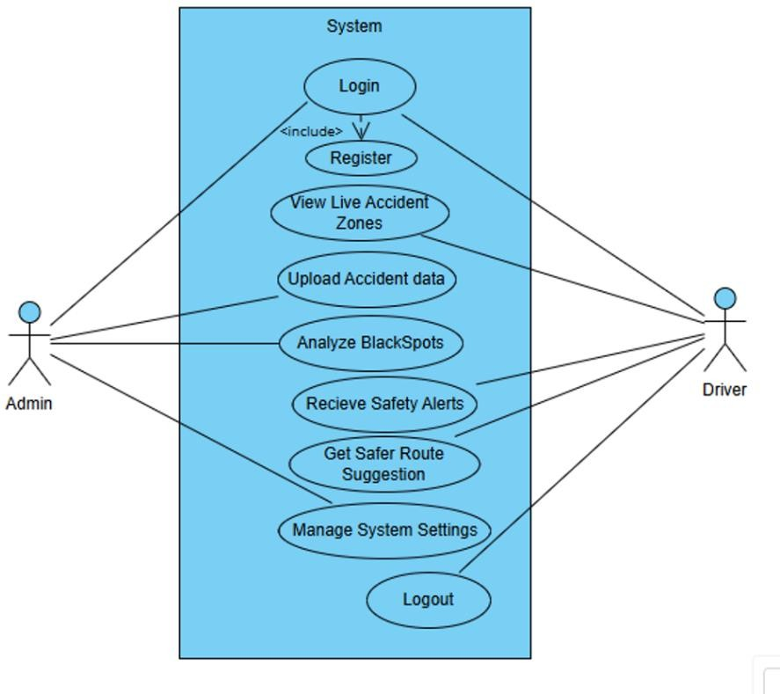

Fig.3.4.1.2 Use diagram

Description:

User: The user will upload the dataset and selects the model for classification and training.
System: The System will check the dataset, and it will preprocess the data therefore, it splits into training and testing and predicts the results

Use Case ID | UC01
Use case Name | Upload Black Spot Dataset
Participating Actors | Admin (Application)
Entry Condition | Black spot dataset file is available
Flow of Events | - Admin uploads accident dataset  - System validates and stores it
Exit Condition | Dataset is successfully uploaded
Target Requirements | Dataset must include valid Feilds
Table 3.4.1.2 (a) Upload dataset

Use Case ID | UC02
Use Case Name | Read Dataset
Participating Actors | System
Entry Condition | Dataset is uploaded and available
Flow of Events | - System loads dataset  - Prepares it for model training
Exit Condition | Dataset is successfully read and ready
Target Requirements | Dataset should be readable and clean
Table 3.4.1.2 (b) Read dataset

Use Case ID | UC03
Use case Name | Model Training
Participating Actors | System
Entry Condition | Dataset is loaded.
Flow of Events | - Application initializes the model training process.  - Model is trained using the loaded dataset.  - Model parameters are optimized.
Exit Condition | Model is successfully trained.
Target Requirements | Accuracy should be high (>90%) for reliable  predictions

Table 3.4.1.2 (c) Model Training

Use Case ID | UC04
Use case Name | Model Testing
Participating Actors | System
Entry Condition | Model is trained.
Flow of Events | - Application tests the model using test datasets.  - Model performance is evaluated.
Exit Condition | Model testing is complete with performance metrics.
Target Requirements | Testing should accurately reflect real-world  performance.
Table 3.4.1.2(d) Model Testing

Use Case ID | UC04
Use case Name | Model Testing
Participating Actors | Application
Entry Condition | User has to select the particular language
Flow of Events | - Application should provide particular language data.  - User can learn from it.
Exit Condition | Model testing is complete with performance metrics.
Target Requirements | Testing should accurately reflect real-world performance and provide a language to learn for the  user.

Table 3.4.1.2 (e) Predict Black Spots on Route

Use Case ID | UC06
Use case Name | Translate Language
Participating Actors | Application
Entry Condition | User should select the Target Language to translate  the text.
Flow of Events | - Application processes the test results.  - Translate Results are Generated
Exit Condition | User views the Generated Results
Target Requirements | Output generation should be quick and accurate and display should be user-friendly and clear.  It provide the translated text as per user requirements.

Table 3.4.1.2 (f) Display Route with Black Spots

Use Case ID | UC06
Use case Name | Predict Results
Participating Actors | Application
Entry Condition | Model testing is complete.
Flow of Events | - Application processes the test results.  - Predicted texts are Generated
Exit Condition | Datasets is successfully loaded. And predict the text
Target Requirements | Output generation should be quick and accurate and  should be user-friendly and clear.

Table 3.4.1.2 (g) Real-Time Alert to User

Use Case ID | UC06
Use case Name | Generate Results
Participating Actors | Application
Entry Condition | Model testing is complete.
Flow of Events | - Application processes the test results.  - Target Results are Generated
Exit Condition | User views the Generated Results
Target Requirements | Output generation should be quick and accurate and  display should be user-friendly and clear.

Table 3.4.1.2 (h) Admin Update Black Spot Data

Sequence Diagram
A sequence diagram is the most commonly used interaction diagram. It simply depicts interaction between objects in a sequential order, i.e., the order in which these interactions take place.
We can also use the terms event diagrams or event scenarios to refer to a sequence diagram. Sequence diagrams describe how and in what order the objects in a system function. These diagrams are widely used by businessmen and software developers to document and understand requirements for new and existing systems.
Sequence diagrams can be useful references for businesses and other organizations. The Purpose of sequence diagrams is:
- Represent the details of a UML use case.
- See how objects and components interact with each other to complete a process.
- Plan and understand the detailed functionality of an existing or future scenario

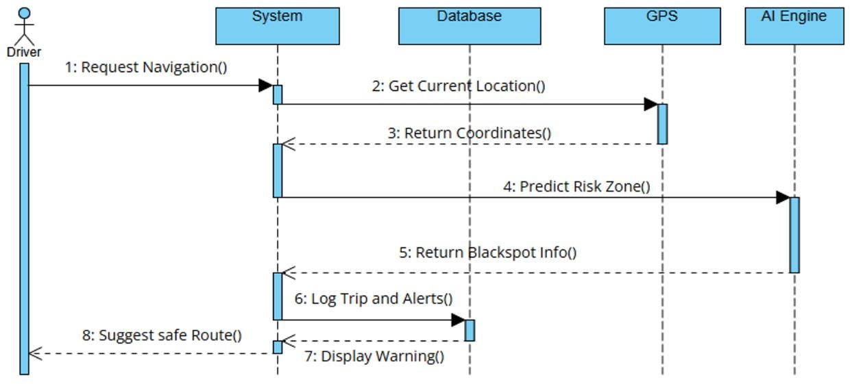

Fig.3.4.2 Sequence Diagram

Activity Diagram
Activity diagrams provide a way to model the workflow of a business process. An activity diagram is typically used for modelling the sequence of workflows. A software company could use activity diagrams to model a software development process. Activity diagrams are graphical representations of workflows of stepwise activities and actions with support for choice, iteration and concurrency. In the Unified Modelling Language, activity diagrams can be used to describe the business and operational step-by-step workflows of components in a system. An activity diagram shows the overall flow of control.
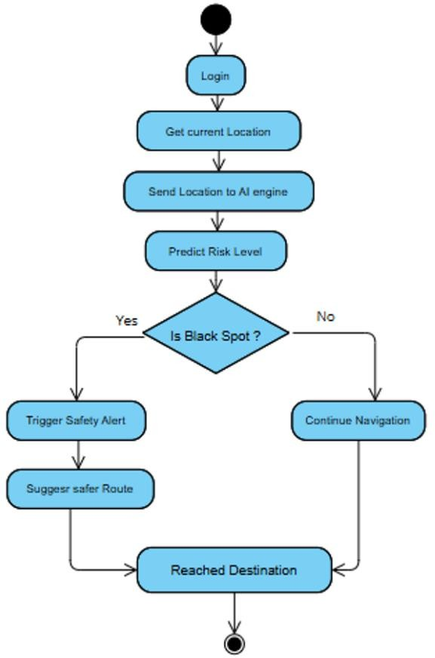

3.4.3 Activity Diagram

Description:

User: the user can do only to operations that is Upload dataset and view results

System: the system can read the uploaded dataset to train and test the dataset and to give targeted text and generate results to display it

SYSTEM DESIGN
System Design is the process of defining the architecture, components, modules, interfaces, and data for a system to satisfy specified requirements. In System design, developers:
- Define design goals of the project
- Decompose the system into smaller sub systems
- Design hardware/software strategies
- Design persistent data management strategies
- Design global control flow strategies
- Design access control policies and
- Design strategies for handling boundary conditions.
- System design is not algorithmic. It is decomposed of several activities. They are:
- Identify Design Goals
- Design the initial subsystem decomposition
- Refine the subsystem decomposition to address the design goals.
System Design is the transform of analysis model into a system design model. Developers define the design goals of the project and decompose the system into smaller subsystems that can be realized by individual teams. Developers also select strategies for building the system, such as the hardware/software platform on which the system will run, the persistent data management strategy, the goal control flow the access control policy and the handling of boundary conditions.

Design Goals
Design goals are the qualities that the system should focus on. Many design goals can be inferred from the non-functional requirements or from the application domain.
User friendly: The system is user friendly because it is easy to use and understand.
Reliability: Proper checks are there for any failure in the system if they exist.

System Architecture
As the complexity of systems increases, the specification of the system decomposition is critical. Moreover, subsystem decomposition is constantly revised whenever new issues are addressed. Subsystems are merged into a single subsystem, a complex subsystem is split into parts, and some subsystems are added to take care of new

functionality. The first iterations over the subsystem decomposition can introduce drastic changes in the system design model.

System Design
The overall project aim is to predict the personality through Machine Learning. With the advancement of artificial intelligence and machine learning (ML), autism can be predicted at quite an early stage. The main aim of this project is to analyze various Machine learning algorithms, used by various researcher like Naive Bayes and SVM and compare the results based on their accuracy and efficiency.
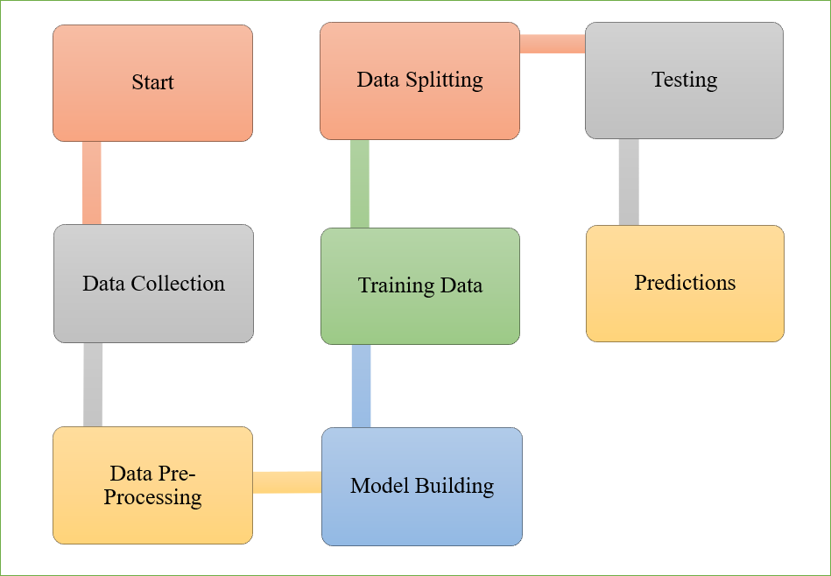

Fig. 4.3 System’s Block Design

Implementation of Project

Input Design

The input design is the link between the information system and the user. It comprises the developing specification and procedures for data preparation and those steps are necessary to put transaction data in to a usable form for processing can be achieved by inspecting the computer to read data from a written or printed document or it can occur by having people keying the data directly into the system. The design of input focuses on controlling the amount of input required, controlling the errors, avoiding delay, avoiding extra steps and keeping the process simple. The input is designed in such a way so that it provides security and ease of use with retaining the privacy.
Input Design considered the following things:
- What data should be given as input?

- How the data should be arranged or coded?
- The dialog to guide the operating personnel in providing input.
- Methods for preparing input validations and steps to follow when error occur.

Objectives

- Input Design is the process of converting a user-oriented description of the input into a computer-based system. This design is important to avoid errors in the data input process and show the correct direction to the management for getting correct information from the computerized system.
- It is achieved by creating user-friendly screens for the data entry to handle large volume of data. The goal of designing input is to make data entry easier and to be free from errors. The data entry screen is designed in such a way that all the data manipulates can be performed. It also provides record viewing facilities.
- When the data is entered it will check for its validity. Data can be entered with the help of screens. Appropriate messages are provided as when needed so that the user will not be in maize of instant. Thus, the objective of input design is to create an input layout that is easy to follow

Output Design

A quality output is one, which meets the requirements of the end user and presents the information clearly. In any system results of processing are communicated to the users and to other system through outputs. In output design it is determined how the information is to be displaced for immediate need and also the hard copy output. It is the most important and direct source information to the user. Efficient and intelligent output design improves the system's relationship to help user decision-making.
Designing computer output should proceed in an organized, well thought out manner; the right output must be developed while ensuring that each output element is designed so that people will find the system can be used easily and effectively. When analyze design computer output, they should identify the specific output that is needed to meet the requirements.

Algorithms
    - Random Forest Algorithm:
Random Forest is a powerful and versatile ensemble learning algorithm that operates by constructing a multitude of decision trees during training time and outputs the class (for classification) or mean prediction (for regression) of the individual trees. It was developed by Leo Breitman and is widely used for both classification and regression problems. Unlike a single decision tree which is prone to overfitting, Random Forest overcomes this by creating an ensemble (forest) of trees trained on random subsets of the data and features, and then aggregates their outputs. This makes the model more accurate, robust, and resistant to noise.
Random Forest is considered one of the most reliable and interpretable machine learning models, especially for tabular datasets. Random Forest is one of the most widely used and reliable machine learning algorithms in the field of data science. It belongs to a family of ensemble learning methods, specifically classified under bagging-based models. The core idea behind Random Forest is to combine the predictions of multiple decision trees to produce a more accurate and stable result.

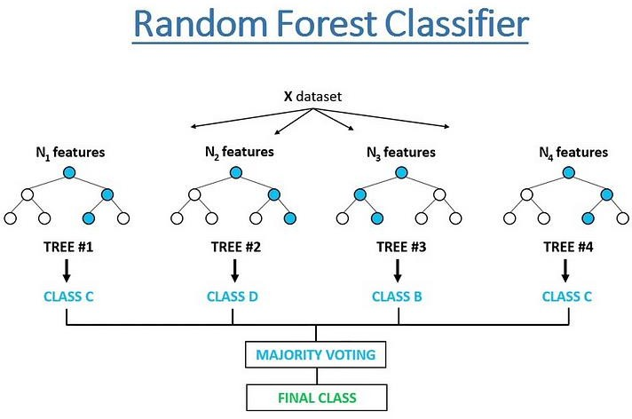

4.5.2. Random Forest Working

The Random Forest Classifier works by constructing a collection of decision trees, each trained on random samples and subsets of features. The predictions from all trees are then aggregated to improve the final result. The major components of Random Forest include Bootstrap Sampling, Random Feature Selection, Tree Construction, and Majority Voting.

.ç^ Bootstrap Sampling

Bootstrap sampling refers to the technique of creating multiple random subsets of the original training data by sampling with replacement. Each subset (called a bootstrap sample) is used to train one decision tree in the forest.
Let:

- DD = original dataset with NN records

- DkD_k = bootstrap sample for tree TkT_k Then, for each tree TkT_k:
- Randomly select NN records from DD with replacement

- This creates diversity between trees and prevents overfitting

¡] ⬛# Random Feature Selection

At each node of every decision tree, instead of using all available features, a random subset of features is selected for splitting. This adds randomness and further reduces correlation among trees.
Let:

- mm = total number of features

- m′m' = number of features considered at each split (m′<mm' < m)

Then:

- For each split node:

Select m′ random features from m\text{Select} m'\text {random features from} m Choose the feature that gives the best split (e.g., based on Gini index or information gai n)\text{Choose the feature that gives the best split (e.g., based on Gini index or information gain)}

. V Decision Tree Construction

Each decision tree in the forest is constructed as follows:

- Starts with a bootstrap sample

- At each node:

  - Choose the best split from the random subset of features

  - Recursively grow branches until a stopping condition is met (e.g., max depth, min samples)
Unlike single decision trees that may overfit, Random Forest trees are not pruned but kept fully grown, since the ensemble will compensate for overfitting through averaging.

Voting / Aggregation (Classification Output)

Once all decision trees are trained, they are used to predict the class label for any new input instance.
Let:

- T1(x), T2(x), ..., Tn(x)T_1(x), T_2(x), ..., T_n(x) be the class predictions of nn trees for input xx
Then:

- The final class label yy is determined by majority voting: y=mode(T1(x), T2(x), ..., Tn(x)) y = \text{mode}(T_1(x), T_2(x), ..., T_n(x))

For regression tasks:

y=1n∑k=1nTk(x)y = \frac{1}{n} \sum_{k=1} ^ {n} T_k(x)

This ensemble approach results in lower variance, better generalization, and higher accuracy than individual decision trees.

Applications of Random Forest Classifier:

Some of the famous applications of LSTM includes:
- Medical Diagnosis: Predicting disease outcomes (e.g., cancer classification, heart disease detection).
- Accident Zone Prediction: Identifying black spots in road safety projects using location-based crash data.
- Text Classification: Email spam detection, sentiment analyze, and document categorization.
- Cybersecurity: Intrusion detection systems (IDS) and anomaly detection.
- Manufacturing: Quality control and predictive maintenance of machinery.
- Financial Services: Credit scoring, fraud detection, and risk assessment in banking.
- Customer Analytics: Churn prediction, segmentation, and recommendation systems in e-commerce.
- Agriculture: Predicting crop yield, disease outbreak in plants based on soil and weather data.
- Bioinformatics: Gene expression classification and protein structure prediction.

CODING

CODING

Coding Approach
The objective of the coding or programming phase is to translate the design of the system produced during the design phase into code in a given programming language, which can be executed by a computer and that performs the computation specified by the design. The coding phase affects both testing and maintenance. The goal of coding is not to reduce the implementation cost, but the goal should be to reduce the cost of later phases.
There are two major approaches for coding any software system. They are Top-Down approach and the bottom-up approach.
Bottom-up Approach can best suit for developing the object-oriented systems. During the system design phase, we decompose the system into an appropriate number of subsystems, for which objects can be modelled independently. These objects exhibit the way the subsystems perform their operations.
Once objects have been modelled, they are implemented by means of coding. Even though related to the same system as the objects are implemented in each other, the Bottom-Up approach is more suitable for coding these objects. In this approach, we first do the coding of objects independently, and then we integrate these modules into one system to which they belong.
This code will first allow the admin to login with a valid user id and password. After this, admin will select the admission or academic module and enter all the students' details branch wise. TPO will select clustering algorithms to identify distinct groups of data modules and enter the details based on academic performance. Reports are generated accordingly and can be viewed by teaching staff and students.

Verification and Validation
Verification is the process of checking that the product built is right. Validation is the process of checking whether the right product is built. During the Development of the system, coding for the object has been thoroughly verified from different aspects regarding their design, in the way they are integrated, etc.
Validations applied to the entire system at two levels:

Form level Validation: Validations of all the inputs given to the system at various points in the forms are validated while navigating to the next form. System raises appropriate custom and pre-defined exceptions to alert the user about the errors that occurred or are likely to occur.
Field level Validation: Validations at the level of individual controls are also applied wherever necessary. System pops up appropriate and sensuous dialogues wherever necessary. In this project, validations are performed on each individual control. If any one of the text field is not filled or any wrong, a click occurs, then the system will generate appropriate exceptions.

Source Code

App.py
import os
import as tk
from tkinter import ttk, messagebox
from PIL import Image, ImageTk
import webbrowser

class BlackSpotApp(tk.Tk):
def __init__(self):
super().__init__()
self.title("Black Spot Detection")
self.geometry("900x600")
self.resizable(False, False)
self.home_page()

def home_page(self):
frame = tk.Frame(self)
frame.pack(expand=True, fill="both")

# Load and set background image
bg_image_path = "homepage_background.png"
if os.path.exists(bg_image_path):
image = Image.open(bg_image_path)
image = image.resize((900, 600), Image.Resampling.LANCZOS)
self.bg_image = ImageTk.PhotoImage(image)
bg_label = tk.Label(frame, image=self.bg_image)
bg_label.place(x=0, y=0, relwidth=1, relheight=1)
else:
messagebox.showerror("Error", f"{bg_image_path} not found.")

# Optional heading (leave empty or set text)
heading = tk.Label(frame, text="", font=("Poppins", 20, "bold"), fg="black", bg="white")
heading.place(relx=0.5, y=80, anchor="center")

# Buttons
button_frame = tk.Frame(frame, bg="white")
button_frame.place(relx=0.5, rely=0.6, anchor="center")

style = ttk.Style()
style.configure("Custom.TButton", font=("Poppins", 12), padding=10)

proceed_btn = ttk.Button(button_frame, text="PROCEED", command=self.open_index_page, style="Custom.TButton")
proceed_btn.grid(row=0, column=0, padx=10)

exit_btn = ttk.Button(button_frame, text="EXIT", command=self.quit, style="Custom.TButton")
exit_btn.grid(row=0, column=1, padx=10)

def open_index_page(self):
html_path = os.path.abspath("index.html")
if os.path.exists(html_path):
try:
# Try to open in Google Chrome
chrome_path = "C:/Program Files/Google/Chrome/Application/chrome.exe %s"
webbrowser.get(chrome_path).open(f"file://{html_path}")
except webbrowser.Error:
# If Chrome is not found, open in the default browser
webbrowser.open(f"file://{html_path}")
self.quit()
else:
messagebox.showerror("Error", "index.html not found.")

if __name__ == "__main__":
app = BlackSpotApp()
app.mainloop()

Home.html

<!DOCTYPE html>
<html lang="en">
<head>
<meta charset="UTF-8">
<title>Black Zone Detection</title>
<meta name="viewport" content="width=device-width, initial-scale=1.0">

<style>
body {
margin: 0;
font-family: "Times New Roman", serif;
background: linear-gradient(135deg, #e8f0f2, #f5f4ea);
}

.container {
width: 80%;
margin: 20px auto;
background: linear-gradient(to right, #f1e7da, #dee6ec);
border: 2px solid black;
padding: 110px;
position: relative;
}

.header {
text-align: centre;
}

.header h2 {
margin: 4px 0;
font-size: 36px;
font-weight: bold;
}

.header p {
margin: 3px 0;
font-size: 20px;
}

.title {
text-align: center;
margin: 40px 0;
font-size: 36px;
font-weight: bold;
}

.buttons {
text-align: center;
margin-bottom: 40px;
}

.buttons button {
padding: 10px 25px;
margin: 0 15px;
font-size: 16px;
border: 1px solid gray;
background-color: #e0e0e0;
cursor: pointer;
}

.buttons button:hover {
background-color: #cfcfcf;
}

.footer {
display: flex;
justify-content: space-between;
margin-top: 60px;
font-size: 20px;
}

.footer div {
width: 45%;
}

.page-number {
position: absolute;
bottom: 10px;
right: 20px;
}

.logo-left {
position: absolute;
top: 30px;
left: 30px;
width: 200px;
}

</style>
</head>
<body>

<div class="container">

<!-- Logos -->
<img src="NSRIT Logo.jpg" class="logo-left" alt="Left Logo">

<!-- Header Section -->
<div class="header">
<h2>NADIMPALLI SATYANARAYANA RAJU </h2>
<h2>INSTITUTE OF TECHNOLOGY (Autonomous) </h2>
<p>Approved by AICET, New Delhi & Permanently Affiliated to JNTU - Gurajada, Vizianagaram </p>
<p>Recognized under Section 2(f) & 12(B) of the UGC Act, 1956| Accredited by NAAC 'A' Grade</p>
<p>SONTYAM, VISAKHAPATNAM - 531 173 </p>
<p><b>Department of Computer Applications</b></p>
</div>

<!-- Title -->
<div class="title">
Black Zone Detection
</div>

<!-- Buttons -->
<div class="buttons">
<button onclick="location.href='index.html'">PROCEED</button>
<button onclick="exitPage()">EXIT</button>

<script>
function exitPage() {
if(window.close) {
window.close();
alert("Thank you for using Black Zone Detection Project. Please close the tab manually. Auto-close not permitted");
}
}
</script>

</div>

<!-- Footer Details -->
<div class="footer">
<div>
<b>PROJECT GUIDE:</b><br>
Mr. K. RAMA KRISHNA<br>
ASSOCIATE PROFESSOR
</div>

<div style="text-align:right;">
<b>BY</b><br>
NAME: NAKKINA LALITHA KAVYA<br>
COURSE: MCA (2024-2026)<br>
ROLL NO: 24NU1F0048
</div>
</div>

<div class="page-number">1</div>

</div>

</body>
</html>

index.html

<!doctype html>
<html lang="en">
<head>
<meta charset="utf-8" />
<meta name="viewport" content="width=device-width, initial-scale=1" />
<title>Blackspot Detection</title>

<!-- Google Fonts -->
<link href="https://fonts.googleapis.com/css2?family=Poppins:wght@400;600;800&display=swap" rel="stylesheet" />

<!-- Bootstrap CSS -->
<link href="https://cdn.jsdelivr.net/npm/bootstrap@5.3.6/dist/css/bootstrap.min.css" rel="stylesheet" />
<style>
body {
font-family: 'Poppins', sans-serif;
margin: 0;
padding: 0;
}
.navbar {
background-color: #0b0f18;
}
.hero-img-wrapper {
margin-top: 70px;
}
.hero-img-wrapper img {
width: 100%;
height: auto;
display: block;
}
.info-section {
min-height: 100vh;
display: flex;

align-items: center;
}
section h2 {
margin-bottom: 1rem;
}
.exit-btn {
position: fixed;
bottom: 20px;
left: 20px;
z-index: 999;
}
.back-btn{
position: fixed;
bottom: 20px;
right: 20px;
z-index: 999;
}

</style>
</head>
<body>

<!-- Prevent auto scroll to hash on refresh -->
<script>
window.addEventListener('load', function () {
if (window.location.hash) {
history.replaceState(null, null, window.location.pathname);
}
});
</script>

<!-- Navbar -->
<nav class="navbar navbar-expand-lg navbar-dark fixed-top shadowsm">
<div class="container">
<a class="navbar-brand d-flex align-items-center" href="#">
<img src="Blackspot Detection.jpg" height="40" class="me-2" alt="Logo" />
<strong>Blackspot Detection</strong>
</a>
<button class="navbar-toggler" type="button" data-bstoggle="collapse" data-bs-target="#navbarNav">
<span class="navbar-toggler-icon"></span>
</button>
<div class="collapse navbar-collapse justify-content-end" id="navbarNav">
<ul class="navbar-nav align-items-center">
<li class="nav-item"><a class="nav-link" href="#abstract">Abstract</a></li>
<li class="nav-item"><a class="nav-link" href="#help">Help</a></li>
<li class="nav-item"><a class="btn btn-outline-warning ms-2" href="register.html">Sign Up</a></li>
</ul>
</div>
</div>
</nav>

<!-- Hero Image -->
<div class="hero-img-wrapper">
<img src="Logo-NSRIT.png" alt="Hero Image" />
</div>

<!-- Blue Box Section -->
<div class="container py-5">
<div class="bg-primary text-white rounded-4 shadow p-4">
<h1 class="fw-bold mb-4 text-center">Black Spot Detection</h1>
<div class="row align-items-center">
<div class="col-md-4 text-start">
<h5 class="fw-bold">PROJECT GUIDE:</h5>
<p class="mb-0">MR.K.Rama Krishna</p>
<p class="mb-0">ASSOCIATE PROFESSOR</p>
</div>
<div class="col-md-4 text-center my-3 my-md-0">
<a href="login.html" class="btn btn-warning fw-bold px-4 py2">Visit Now</a>
</div>
<div class="col-md-4 text-end">
<h5 class="fw-bold">BY</h5>
<p class="mb-0">NAME: N.Lalitha kavya</p>
<p class="mb-0">COURSE: MCA (2024–2026)</p>
<p class="mb-0">ROLL NO: 24NU1F0048</p>
</div>
</div>
</div>
</div>

<!-- Abstract Section -->
<section class="info-section bg-light" id="abstract">
<div class="container px-4">
<h2 class="text-center text-dark fw-bold" style="font-size: 30px;">Abstract</h2>
<p class="fs-5 text-dark text-justify">
Road accidents are a leading cause of death and injury worldwide, often occurring repeatedly in specific high-risk zones known as Black Spots.
This project aims to develop an intelligent Black Spot Prediction System that uses Artificial Intelligence (AI) and Global Positioning System (GPS)
technologies to enhance road safety by identifying and predicting accident-prone areas in real time.
</p>
<p class="fs-5 text-dark text-justify">
The system collects historical accident data, analyzes geographical patterns, and applies machine learning algorithms to detect high-risk locations.
When a driver enters or approaches a potential Black Spot, the system issues live safety alerts and suggests alternate, safer routes.
The integration of real-time GPS tracking enables continuous monitoring of the user's location.
</p>
<p class="fs-5 text-dark text-justify">
This project uses Artificial Intelligence (AI) and Machine Learning (ML) to analyze past accident data and predict high-risk zones. The system studies road conditions, traffic flow, accident history, and weather factors
to identify why accidents happen in specific areas. Once a Black Zone is detected, the system provides real-time alerts to drivers and suggests safer alternate routes.
</p>
</div>
</section>

<!-- Help Section -->
<section class="info-section bg-white" id="help">
<div class="container px-4">
<h2 class="text-center text-dark fw-bold" style="font-size: 30px;">Help & User Guide</h2>

<p class="fs-5 text-dark">
</p>
<p>Welcome to the Black Spot Prediction System. This guide will help you understand how to use the system step by step.</p>
<p><strong>Step 1:</strong> Start by registering or logging in using your email, password, and mobile number with OTP verification.</p>
<p><strong>Step 2:</strong> After successful login, click the “Proceed” button to launch the interactive map interface.</p>
<p><strong>Step 3:</strong> In the map page, enter your <strong>starting location</strong> (Arrival) and <strong>destination</strong>.</p>
<p><strong>Step 4:</strong> Click on “Show Route & Black Spots”. The system will display your route with accident-prone zones (Black Spots) marked on the map.</p>
<p><strong>Step 5:</strong> Click on any black spot marker to see
detailed information such as:
<ul>
<li> Risk alert (e.g., School Zone, Sharp Curve)</li>
<li> GPS coordinates</li>
<li> Safety tips (e.g., Drive slow, Use low beam)</li>
<li> 'Show Reason' button to know why it's a black spot</li>
</ul>
</p>
</div>

</div>
</section>

<!-- Exit Button -->
<button onclick="exitPage()" class="btn btn-warning fw-bold px-4 py-2 exit-btn">Exit</button>

<!-- Back to Home -->
<a href="Home.html" class="btn btn-warning fw-bold px-4 py-2 back-btn">
Back
</a>

<!-- Exit Function -->
<script>
function exitPage() {
if (window.close) {
window.close();
alert("If this tab doesn't close automatically, please close it manually. Browser blocked auto-close.");
} else {
alert("Please close the tab manually. Auto-close not permitted.");
}
}
</script>

<!-- Manual Scroll Fix for Navbar Offset -->
<script>
function scrollToTarget(id) {
const target = document.querySelector(id);
const yOffset = -70; // height of your fixed navbar
const y = target.getBoundingClientRect().top + window.pageYOffset + yOffset;
window.scrollTo({ top: y, behavior: 'smooth' });
}

document.querySelectorAll('a.nav-link').forEach(link => {
link.addEventListener('click', function (e) {
e.preventDefault();
scrollToTarget(this.getAttribute('href'));
});
});
</script>

<!-- Bootstrap JS -->
<script src="https://cdn.jsdelivr.net/npm/bootstrap@5.3.6/dist/js/bootstrap.bundle.min.js"></script>
</body>
</html>

Register.html

<!DOCTYPE html>

<html lang="en">

<head>

<meta charset="UTF-8">

<meta name="viewport" content="width=device-width, initial-scale=1.0">

<title>Register - Black Spot App </title>

<style>

body {

background: linear-gradient(135deg,#dbeafe,#fef9c3);

font-family: 'Segoe UI', sans-serif;

display: flex;

justify-content: center;

align-items: center;

height: 100vh;

margin: 0;

}

.form-container {

background: white;

padding: 35px;

border-radius: 15px;

box-shadow: 0 10px 25px rgba(0,0,0,0.1);

width: 400px;

}

h2 {

text-align: center;

margin-bottom:25px;

}

input {

width: 100%;

padding: 12px;

margin: 10px 0;

border-radius: 8px;

border: 1px solid #ccc;

font-size:15px;

box-sizing:border-box;

}

.input-group{

display:flex;

gap:8px;

}

.input-group input:first-child{

width:80px

}

.captcha-group{

display: flex;

align-items: center;

}

.captcha-box{

background: #f0f0f0;

padding: 10px 15px;

border: 1px dashed #999;

font-weight: bold;

border-radius: 6px;

margin-right:10px;

min-width: 80px;

text-align:center;

}

button {

width: 100%;

padding: 12px;

margin-top: 10px;

font-weight: bold;

border: none;

border-radius: 8px;

background: #007bff;

color: white;

font-size: 16px;

cursor: pointer;

}

button:hover:enabled{

background: #0056b3;

}

.message {

text-align: center;

margin-top: 10px;

}

.success{color: green;}

.error{color:red;}

.password-wrapper{

position:relative;

}

.password-wrapper input{

padding-right:40px;

}

.toggle-password{

position: absolute;

right: 12px;

top: 50%;

transform: translateY(-50%);

cursor: pointer;

}

.login-link {

text-align: center;

margin-top: 15px;

}

.login-link a {

color: #007bff;

text-decoration: none;

font-weight: 500;

}

.login-link a:hover {

text-decoration: underline;

}

</style>

</head>

<body>

<div class="form-container">

<h2>Create Account</h2>

<form onsubmit="return verifyOTP(event)">

<input type="email" id="email" placeholder="Email" required>

<div class="password-wrapper">

<input type="password" id="password" placeholder="Password" required>

<span class="toggle-password" onclick="togglePassword()"></span>

</div>

<div class="input-group">

<input type="text" value="+91" readonly>

<input type="text" id="phone" placeholder="Phone Number" maxlength="10" required>

</div>

<div class="captcha-group">

<div class="captcha-box" id="captchaText"></div>

<input type="text" id="captchaInput" placeholder="Enter Captcha" required>

</div>

<button type="button" onclick="sendOTP()">Send OTP</button>

<input type="text" id="otp" placeholder="Enter OTP" style="display:none;">

<button type="submit" id="registerBtn" style="display:none;">Register</button>

<p id="message" class="message"></p>

<!-- ✅ Added Login Link -->

<div class="login-link">

Already registered? <a href="login.html">Login here</a>

</div>

</form>

</div>

<script>

const captchaText=document.getElementById("captchaText");

const messageEl=document.getElementById("message");

function togglePassword(){

const pwd=document.getElementById("password");

pwd.type=pwd.type==="password"?"text":"password";

}

function generateCaptcha(){

const chars="ABCDEFGHIJKLMNOPQRSTUVWXYZ0123456789";

let captcha="";

for(let i=0;i<4;i++){

captcha+=chars[Math.floor(Math.random()*chars.length)];

}

captchaText.textContent=captcha;

}

generateCaptcha();

async function sendOTP(){

const phone=document.getElementById("phone").value.trim();

const captchaInput=document.getElementById("captchaInput").value.trim();

if(captchaInput!==captchaText.textContent){

messageEl.textContent="Captcha incorrect!";

messageEl.className="message error";

generateCaptcha();

return;

}

if(!/^\d{10}$/.test(phone)){

messageEl.textContent="Enter valid 10-digit phone!";

messageEl.className="message error";

return;

}

messageEl.textContent="OTP sent (demo mode)";

messageEl.className="message success";

document.getElementById("otp").style.display="block";

document.getElementById("registerBtn").style.display="block";

}

function verifyOTP(event){

event.preventDefault();

const otp=document.getElementById("otp").value;

if(otp==="1234"){ // demo OTP

const email = document.getElementById("email").value.trim();

const password = document.getElementById("password").value.trim();

// Get existing users

let users = JSON.parse(localStorage.getItem("useres")) || [];

// Check if user already exists

const userExists = users.find(user => user.email === email);

if(userExists){

messageE1.textcontant="User already registered!";

messageEl.className=",message error";

return;

}

// Create new user object

const newUser = {

email: email,

password: password,

phone: phone

};

// Add new user

users.push(newUser);

// Save permanently in localStorage

localStorage.setItem("userEmail", email);

localStorage.setItem("userPassword", password);

messageEl.textContent="Registered Successfully!";

messageEl.className="message success";

setTimeout(()=>{

window.location.href="login.html";

},2000);

}else{

messageEl.textContent="Invalid OTP!";

messageEl.className="message error";

}

}

</script>

</body>

</html>

Login.html

<!DOCTYPE html>
<html lang="en">
<head>
<meta charset="UTF-8">
<meta name="viewport" content="width=device-width, initial-scale=1.0">
<title>Login</title>

<style>
body {
background: #eef2f5;
font-family: 'Segoe UI', sans-serif;
display: flex;
justify-content: center;
align-items: center;
height: 100vh;
margin: 0;
}

.container {
background: white;
padding: 30px;
border-radius: 15px;
box-shadow: 0 10px 25px rgba(0,0,0,0.1);
width: 350px;
}
.register-link {
color: black;
text-align: center;
padding: 15px;
font-size: 14px;
}
.register-link:hover {
color: #1e40af;
}

h2 {
text-align: center;
font-size: 30px;
}
p {
text-align: center;
font-size: 14px;
}

input {
width: 100%;
padding: 12px;
margin: 10px 0;
border-radius: 8px;
border: 1px solid #ccc;
box-sizing: border-box;
}

button {
width: 100%;
padding: 14px;
font-size: 12px;
margin: 10px 0;
border: none;
border-radius: 8px;
background: #28a745;
color: white;
cursor: pointer;
}

button:hover { background: #1e7e34; }
.message { text-align: center; margin-top: 10px; }
.success { color: green; }
.error { color: red; }
</style>
</head>

<body>

<div class="container">
<h2>WELCOME BACK</h2>
<P>Login to Continue to Blackspot Detection</P>

<form onsubmit="loginUser(event)">
<input type="email" id="email" placeholder="Email" required>
<input type="password" id="password" placeholder="Password" required>
<button type="submit">Login</button>

<!-- ✅ Added Register Link -->
<div class="register-link">
New User? <a href="register.html">Register here</a>
</div>

<p id="message" class="message"></p>
</div>

<script>
function loginUser(event) {
event.preventDefault();

const email = document.getElementById("email").value.trim();
const password = document.getElementById("password").value.trim();

const savedEmail = localStorage.getItem("userEmail");
const savedPassword = localStorage.getItem("userPassword");

if(email === savedEmail && password === savedPassword){
alert("Login Successful");

// save login session
localStorage.setItem("isLoggedIn", "true");

// go to dashboard
window.location.href = "dashboard.html";
} else {
alert("Invalid email or password");
}

}
</script>

</body>
</html>

Dashboard.html

<!DOCTYPE html>
<html lang="en">
<head>
<meta charset="UTF-8">
<meta name="viewport" content="width=device-width, initial-scale=1.0">
<title>Black Spot Prediction System</title>

<!-- Font & Icons -->
<link href="https://fonts.googleapis.com/css2?family=Poppins:wght@400;600&display=swap" rel="stylesheet">
<link rel="stylesheet" href="https://cdnjs.cloudflare.com/ajax/libs/font-awesome/6.5.0/css/all.min.css">

<style>
* {
margin: 0;
padding: 0;
box-sizing: border-box;
font-family: 'Poppins', sans-serif;
}

body {
height: 100vh;
display: flex;
justify-content: center;
align-items: center;
background: linear-gradient(to bottom, #2c6fb7, #4fa3d1);
}

.card {
background: #f4f4f4;
padding: 40px;
border-radius: 12px;
text-align: center;
width: 600px;
box-shadow: 0 10px 25px rgba(0, 0, 0, 0.2);
}

.card h1 {
color: #1e4f8a;
font-weight: 600;
margin-bottom: 15px;
}

.card p {
color: #555;
margin-bottom: 30px;
}

.buttons {
display: flex;
justify-content: center;
gap: 20px;
}

.btn {
background-color: #2c6fb7;
color: white;
padding: 12px 20px;
border: none;
border-radius: 8px;
cursor: pointer;
font-size: 14px;
transition: 0.3s ease;
display: flex;
align-items: center;
gap: 8px;
}

.btn:hover {
background-color: #1e4f8a;
transform: translateY(-2px);
}
</style>
</head>

<body>

<div class="card">
<h1>Welcome to Black Spot Prediction System</h1>
<p>This dashboard will help you track accident zones using real-time GPS data.</p>

<div class="buttons">
<button class="btn" onclick="location.href='map.html'">
<i class="fa-solid fa-magnifying-glass"></i>
View Live Map
</button>

<button class="btn" onclick="location.href='Black_spot_app.html'">
<i class="fa-solid fa-route"></i>
Directions
</button>

<button class="btn" onclick="logout()">
<i class="fa-solid fa-right-from-bracket"></i>
Logout
</button>

<script>
function logout(){
alert("Logged out successfully");
window.location.href = "login.html";
}
</script>

</div>
</div>

</body>
</html>

Blackspot-app.html

<!DOCTYPE html>
<html lang="en">
<head>
<meta charset="UTF-8" />
<meta name="viewport" content="width=device-width, initial-scale=1.0" />
<title>Live Map | Black Spot Prediction</title>
<link rel="stylesheet" href="https://unpkg.com/leaflet@1.9.4/dist/leaflet.css" />
<link rel="stylesheet" href="https://unpkg.com/leaflet-routing-machine@3.2.12/dist/leaflet-routing-machine.css" />
<style>
body, html {
margin: 0;
padding: 0;
font-family: 'Segoe UI', sans-serif;
}

#map {
height: 100vh;
width: 100%;
}

.map-form {
position: absolute;
top: 20px;
left: 20px;
background: #fff;
padding: 20px;
border-radius: 10px;
box-shadow: 0 4px 10px rgba(0,0,0,0.1);
z-index: 999;
width: 260px;
}

.map-form h2 {
margin-top: 0;
font-size: 18px;
}

.map-form input,
.map-form button {
width: 100%;
padding: 8px;
margin: 5px 0;
border-radius: 5px;
border: 1px solid #ccc;
}

.map-form button {
background-color: #007bff;
border: none;
color: white;
font-weight: bold;
cursor: pointer;
}

.map-form button:hover {
background-color: #0056b3;
}

.swap-btn {
text-align: center;
cursor: pointer;
margin: 5px 0;
}

.swap-btn span {
font-size: 20px;
user-select: none;
}

.distance-time {
margin-top: 10px;
font-weight: bold;
color: green;
}

/* ✅ Blackspot Table Styling */
#blackspotAutoTable {
position: absolute;
right: 20px;
bottom: 20px;
width: 400px;
background: white;
border-radius: 10px;
box-shadow: 0 4px 10px rgba(0,0,0,0.2);
padding: 10px;
z-index: 999;
display: none;
}

#blackspotAutoTable h3 {
margin: 0;
font-size: 16px;
text-align: left;
}

#routeSummary {
text-align: center;
margin: 8px 0 10px 0;
font-weight: bold;
font-size: 14px;
}

.scroll-table {
max-height: 160px;
overflow-y: auto;
}

.scroll-table table {
width: 100%;
border-collapse: collapse;
font-size: 13px;
table-layout: fixed;
}

.scroll-table thead {
background-color: #f0f0f0;
display: table;
width: 100%;
table-layout: fixed;
}

.scroll-table tbody {
display: block;
max-height: 130px;
overflow-y: auto;
width: 100%;
}

.scroll-table th, .scroll-table td {
padding: 6px;
border: 1px solid #ccc;
text-align: left;
}

.scroll-table td:nth-child(2),
.scroll-table th:nth-child(2) {
width: 90px;
white-space: nowrap;
}

.scroll-table td:nth-child(3),
.scroll-table th:nth-child(3) {
width: 120px;
white-space: nowrap;
}

.scroll-table tr {
display: table;
width: 100%;
table-layout: fixed;
}
</style>
<script src="https://unpkg.com/leaflet@1.9.4/dist/leaflet.js"></script>
<script src="https://unpkg.com/leaflet-routing-machine@3.2.12/dist/leaflet-routing-machine.min.js"></script>
</head>
<body>

<div class="map-form">
<h2>Enter Route</h2>
<input type="text" id="startPlace" placeholder="Arrival (e.g., Hyderabad)" />
<div class="swap-btn" onclick="swapPlaces()"><span>⇅</span></div>
<input type="text" id="endPlace" placeholder="Destination (e.g., Visakhapatnam)" />
<button onclick="geocodeAndShowRoute()">Show Route & Black Spots</button>
<div id="distanceTime" class="distance-time"></div>
</div>

<div id="map"></div>

<!-- ✅ Blackspot List Box -->
<div id="blackspotAutoTable">
<h3>Blackspot List</h3>
<div id="routeSummary">
<span style="color:red;">●</span> <span id="srcName">Source</span>
&nbsp;----->&nbsp;
<span style="color:green;">●</span> <span id="dstName">Destination</span>
</div>

<div class="scroll-table">
<table>
<thead>
<tr>
<th>Blackspot</th>
<th>Date</th>
<th>Lat, Lng</th>
</tr>
</thead>
<tbody id="autoTableBody"></tbody>
</table>
</div>
</div>

<script>
let map, control;

function capitalizeWords(str) {
return str.replace(/\b\w/g, c => c.toUpperCase());
}

window.onload = function () {
map = L.map("map").setView([17.385044, 78.486671], 6);
L.tileLayer('https://{s}.tile.openstreetmap.org/{z}/{x}/{y}.png', {
attribution: '&copy; OpenStreetMap contributors'
}).addTo(map);
};

function swapPlaces() {
const start = document.getElementById("startPlace").value;
const end = document.getElementById("endPlace").value;
document.getElementById("startPlace").value = end;
document.getElementById("endPlace").value = start;
}

async function getCoordinates(place) {
const response = await fetch(`https://nominatim.openstreetmap.org/search?format=json&q=${place}`);
const data = await response.json();
if (data.length > 0) return [parseFloat(data[0].lat), parseFloat(data[0].lon)];
alert(`Location not found: ${place}`);
return null;
}

async function geocodeAndShowRoute() {
const startName = document.getElementById("startPlace").value;
const endName = document.getElementById("endPlace").value;
const startCoords = await getCoordinates(startName);
const endCoords = await getCoordinates(endName);
if (!startCoords || !endCoords) return;

document.getElementById("srcName").innerText = capitalizeWords(startName);
document.getElementById("dstName").innerText = capitalizeWords(endName);

if (map) map.remove();
map = L.map("map").setView(startCoords, 13);
L.tileLayer('https://{s}.tile.openstreetmap.org/{z}/{x}/{y}.png', {
attribution: '&copy; OpenStreetMap contributors'
}).addTo(map);

control = L.Routing.control({
waypoints: [L.latLng(startCoords[0], startCoords[1]), L.latLng(endCoords[0], endCoords[1])],
routeWhileDragging: false,
createMarker: () => null
}).addTo(map);

control.on('routesfound', function(e) {
const route = e.routes[0];
const coords = route.coordinates;

const dist = (route.summary.totalDistance / 1000).toFixed(2);
const time = Math.round(route.summary.totalTime / 60);
document.getElementById("distanceTime").innerHTML = `Distance: ${dist} km<br>Time: ${time} min`;

L.polyline(coords, {
color: 'red',
weight: 6,
opacity: 0.8
}).addTo(map);

const messages = [
"⚠️ Prone Accident Area",
"🏫 School Zone - Drive Slow",
"⚠️ Long Curve Ahead",
"🔄 Sharp Turning Point",
"🚧 Under Maintenance",
"💧 Slippery Road in Monsoon",
"⛔ Blind Spot - Limited Visibility",
"🚸 Pedestrian Crossing Zone"
];

const aiTips = [
"Slow down — this curve has sharp edges.",
"Stay alert for pedestrians crossing nearby.",
"Maintain speed below 40 km/h on this stretch.",
"Use low beam at night in this zone.",
"Avoid overtaking — narrow lane ahead.",
"Road may be slippery during rain — drive carefully."
];

const tableBody = document.getElementById("autoTableBody");
tableBody.innerHTML = "";
let lastMarkerCoords = null;
let msgIndex = 0;
let addedCount = 0;

coords.forEach((point, idx) => {
if (idx > 10 && idx % 50 === 0) {
if (!lastMarkerCoords || map.distance(point, lastMarkerCoords) > 2000) {
const lat = point.lat.toFixed(6);
const lng = point.lng.toFixed(6);
const message = messages[msgIndex % messages.length];
const ai = aiTips[msgIndex % aiTips.length];
const date = `2026-${1 + (msgIndex % 2)}-${3 + (msgIndex % 10)}`;

L.marker([point.lat, point.lng], {
icon: L.icon({
iconUrl: 'https://cdn-icons-png.flaticon.com/512/684/684908.png',
iconSize: [25, 25]
})
}).addTo(map).bindPopup(`
<b>${message}</b><br>
<b>Latitude:</b> ${lat}<br>
<b>Longitude:</b> ${lng}<br>
💡 <b>Tip:</b> ${ai}<br><br>
📷 <i>Reported on ${date}</i><br>
<button onclick="showReason('${message}', ${lat}, ${lng}, ${msgIndex})"
style="margin-top:6px;padding:5px 10px;font-size:14px;border:none;background:#222;color:white;border-radius:5px;cursor:pointer;">
🧠 Show Reason
</button>
`);

const row = document.createElement("tr");
row.innerHTML = `
<td>${message}</td>
<td>${date}</td>
<td>${lat}, ${lng}</td>
`;
tableBody.appendChild(row);
document.getElementById("blackspotAutoTable").style.display = "block";

lastMarkerCoords = point;
msgIndex++;
addedCount++;
}
}
});

if (addedCount === 0) {
document.getElementById("blackspotAutoTable").style.display = "none";
}
});
}

function showReason(message, lat, lng, index) {
let reason = "No specific reason found.";
if (message.includes("School")) reason = `This area is marked as a School Zone because a school exists nearby.`;
else if (message.includes("Curve")) reason = `Long curve detected with an angle over 38°.`;
else if (message.includes("Sharp")) reason = `Sharp turn detected with tight radius.`;
else if (message.includes("Prone")) reason = `Based on accident history, this is a prone area.`;
else if (message.includes("Slippery")) reason = `Road may be slippery during monsoon.`;
else if (message.includes("Blind")) reason = `Limited visibility curve — marked as blind spot.`;
else if (message.includes("Crossing")) reason = `Pedestrian crossing due to nearby schools/markets.`;
alert(`🧠 Reason for ${message}\n\n${reason}`);
}
</script>
</body>
</html>

Server.js

require('dotenv').config();
const express = require('express');
const cors = require('cors');
const mongoose = require('mongoose');
const bodyParser = require('body-parser');
const twilio = require('twilio');
const app = express();
app.use(cors());
app.use(bodyParser.json());

// MongoDB Connection
mongoose.connect(process.env.MONGO_URI, {
useNewUrlParser: true,
useUnifiedTopology: true
}).then(() => console.log(" MongoDB Connected"))
.catch(err => console.error(" MongoDB Error:", err));

// User Schema
const userSchema = new mongoose.Schema({
email: String,
password: String,
phone: String,
role: {
type: String,
default: 'user' // 'user' or 'owner'
}
});
const User = mongoose.model("User", userSchema);

// Twilio Setup
const accountSid = process.env.TWILIO_ACCOUNT_SID;
const authToken = process.env.TWILIO_AUTH_TOKEN;
const serviceSid = process.env.TWILIO_VERIFY_SERVICE_SID;
const client = twilio(accountSid, authToken);

// Send OTP
app.post('/send-otp', async (req, res) => {
const { phone } = req.body;
try {
const verification = await client.verify.v2
.services(serviceSid)
.verifications
.create({ to: phone, channel: 'sms' });

console.log(' OTP Sent:', verification.sid);
res.json({ success: true });
} catch (error) {
console.error(' OTP Send Error:', error.message);
res.json({ success: false, error: error.message });
}
});
// Verify OTP & Register User
app.post('/verify-otp', async (req, res) => {
const { phone, otp, email, password } = req.body;

try {
const verificationCheck = await client.verify.v2
.services(serviceSid)
.verificationChecks
.create({ to: phone, code: otp });

if (verificationCheck.status === 'approved') {
let user = await User.findOne({ phone });

const role = email === "owner@admin.com" ? "owner" : "user";

if (!user) {
user = new User({ email, password, phone, role });
} else {
user.email = email;
user.password = password;
user.role = role;
}

await user.save();
console.log(" User Registered or Updated:", email);

res.json({ success: true });
} else {
res.json({ success: false, error: "Invalid OTP" });
}
} catch (error) {
console.error(' OTP Verify Error:', error.message);
res.json({ success: false, error: error.message });
}
});

// Login
app.post('/login', async (req, res) => {
const { username, password } = req.body;
try {
const user = await User.findOne({
$or: [{ email: username }, { phone: username }],
password
});

if (user) {
res.json({ success: true, role: user.role });
} else {
res.json({ success: false, error: "Invalid credentials" });
}
} catch (error) {
console.error(' Login Error:', error.message);
res.json({ success: false, error: "Server error" });
}
});
// Start Server
app.listen(3000, () => {
console.log(' Server running on http://localhost:3000');
});

Map.html
<!DOCTYPE html>
<html>
<head>
<title>Live Map - Black Spot Prediction</title>
<meta charset="utf-8" />
<meta name="viewport" content="width=device-width, initialscale=1.0" />

<!-- Leaflet CSS (no integrity, no crossorigin) -->
<link rel="stylesheet" href="https://unpkg.com/leaflet@1.9.4/dist/leaflet.css" />
<style>
#map {
height: 100vh;
width: 100%;
}
</style>
</head>
<body>
<div id="map"></div>

<!-- Leaflet JS (no integrity, no crossorigin) -->
<script
src="https://unpkg.com/leaflet@1.9.4/dist/leaflet.js">
</script>

<script>
// Initialize map
const map = L.map("map").setView([17.776279, 83.349832], 12.2);

// Add OpenStreetMap tiles
L.tileLayer("https://{s}.tile.openstreetmap.org/{z}/{x}/{y}.png", {
attribution: "&copy; OpenStreetMap contributors"
}).addTo(map);

// Optional user location
if (navigator.geolocation) {
navigator.geolocation.getCurrentPosition((position) => {
const lat = position.coords.latitude;
const lng = position.coords.longitude;

map.setView([lat, lng], 14);

L.marker([lat, lng])
.addTo(map)
.bindPopup(" You are here")
.openPopup();
});
}

// Dummy black spot markers
const blackSpots = [
{ lat: 17.809115, lng: 83.355470, label: "Black Spot 1" },
{ lat: 17.724577, lng: 83.307326, label: "Black Spot 2" } ];

blackSpots.forEach((spot) => {
L.marker([spot.lat, spot.lng])
.addTo(map)
.bindPopup(" " + spot.label);
});
</script>
</body>
</html>

Script.js

async function getCoordinates(place) {
const response = await
fetch(`https://nominatim.openstreetmap.org/search?format=json&q=${place}`);
const data = await response.json();
if (data && data.length > 0) {
return [parseFloat(data[0].lat), parseFloat(data[0].lon)];
}
alert(`Location not found: ${place}`);
return null;
}
async function geocodeAndShowMap() {
const startName = document.getElementById("startPlace").value;
const endName = document.getElementById("endPlace").value;
const startCoords = await getCoordinates(startName);
const endCoords = await getCoordinates(endName);
if (!startCoords || !endCoords) return;

document.getElementById("map").style.display = "block";
const map = L.map("map").setView(startCoords, 7);
L.tileLayer("https://{s}.tile.openstreetmap.org/{z}/{x}/{y}.png", {
attribution: '&copy; OpenStreetMap contributors'
}). addTo(map);

// Add markers
L.marker(startCoords).addTo(map).bindPopup(" Arrival").openPopup();
L.marker(endCoords).addTo(map).bindPopup(" Destination");

// Draw path
const route = L.polyline([startCoords, endCoords], { color: "blue" }).addTo(map);
map.fitBounds(route.getBounds());

// Black spots around Visakhapatnam
const blackSpots = [
{ name: "Gajuwaka Junction", lat: 17.6803, lng: 83.2162 },
{ name: "NAD Junction", lat: 17.7330, lng: 83.3014 },
{ name: "Maddilapalem", lat: 17.7384, lng: 83.3203 } ];
blackSpots.forEach(spot => {
const dist = Math.sqrt(Math.pow(spot.lat - startCoords[0], 2) + Math.pow(spot.lng - startCoords[1], 2));
if (dist < 1) {
L.marker([spot.lat, spot.lng])
.addTo(map)
.bindPopup(`<b>${spot.name}</b><br> Black Spot`);
}
});
}

Train_model.py

import pandas as pd
from sklearn.ensemble import RandomForestClassifier
from sklearn.model_selection import train_test_split
from sklearn.metrics import accuracy_score
import joblib

# Load dataset
df = pd.read_csv("blackspot_data.csv")

# Features and label
X = df[["latitude", "longitude"]]
y = df["is_blackspot"]

# Split dataset
X_train, X_test, y_train, y_test = train_test_split(X, y, test_size=0.2, random_state=42)

# Train model
model = RandomForestClassifier(n_estimators=100, random_state=42)
model.fit(X_train, y_train)

# Evaluate model
y_pred = model.predict(X_test)
accuracy = accuracy_score(y_test, y_pred)
print(f"Model trained with accuracy: {accuracy * 100:.2f}%")

# Save model
joblib.dump(model, "blackspot_model.pkl")
print("Model saved as blackspot_model.pkl")

TESTING

TESTING
Testing is the process of finding differences between the expected behaviour specified by system models and the observed behaviour of the system. Testing is a critical role in quality assurance and ensuring the reliability of development and these errors will be reflected in the code, so the application should be thoroughly tested and validated.
Unit testing finds the differences between the object design model and its corresponding components. Structural testing finds differences between the system design model and a subset of integrated subsystems. Functional testing finds differences between the use case model and the system. Finally, performance testing, finds differences between non-functional requirements and actual system performance. From modelling point of view, testing is the attempt of falsification of the system with respect to the system models. The goal of testing is to design tests that exercise defects in the system and to reveal problems.

Testing Activities
Testing a large system is a complex activity and like any complex activity. It has to be broke into smaller activities. Thus, incremental testing was performed on the project ie, components and subsystems of the system were tested separately before integrating them to form the subsystem for system testing

Testing Types
    - Unit Testing
Unit testing focuses on the building blocks of the software system that is the objects and subsystems. There are three motivations behind focusing on components. First unit testing reduces the complexity of overall test activities allowing focus on smaller units of the system, second unit testing makes it easier to pinpoint and correct faults given that few components are involved in the rest. Third unit testing allows parallelism in the testing activities, that is each component are involved in the test. Third unit testing allows parallelism in the testing activity, so that each component can be tested independently of one another. The following are some unit testing techniques.
Equivalence testing: It is a black box testing technique that minimises the number of test cases. The possible inputs are partitioned into equivalence classes, and a test case is selected for each class.

Boundary testing: It is a special case of equivalence testing and focuses on the conditions at the boundary of the equivalence classes. Boundary testing requires that the elements be selected from the edges of the equivalence classes.
Path testing: It is a white box testing technique that identifies faults in the implementation of the component the assumption here is that exercising all possible paths through the code at least once. Most faults will trigger failure. This acquires knowledge of source code.

Integrating Testing
Integration testing defects faults that have not been detected. During unit testing by focusing on small groups on components two or more components are integrated and tested, and once tests do not reveal any new faults, additional components are added to the group. This procedure allows testing of increasing more complex parts on the system while keeping the location of potential faults relatively small. I have used the following approach to implement and integrate testing
Top-down testing strategy unit tests the components of the top layer and then integrated the components of the next layer down. When all components of the new layer have been tested together, the next layer is selected. This was repeated until all layers are combined and involved in the test.

Validation Testing
The systems completely assembled as package, the interfacing have been uncovered and corrected, and a final series of software tests are validation testing. The validation testing is nothing but validation success when system functions in a manner that can be reasonably expected by the customer. The system validation had done by series of Black-box test methods.

System Testing
- System testing ensures that the complete system complies with the functional requirements and non-functional requirements of the system, the following are some system testing activities.
- Functional testing finds differences between the functional between the functional requirements and the system. This is a black box testing technique. Test cases are divided from the use case model.

- Performance testing finds differences between the design and the system, the design goals are derived from the functional requirements.
- Pilot testing the system is installed and used by a selected set of users to exercise the system as if it had been permanently installed.
5. Acceptance testing, I have followed benchmarks testing in a benchmark testing the client prepares a set of test cases represent typical conditions under which the system operates. In our project, there are no existing benchmarks.
Installation testing, the system is installed in the target environment

Various Types of Testing
    - White-Box Testing
Knowing the internal workings of the product, tests can be conducted to ensure that the internal operation of the product performs according to specifications and all internal components have been adequately exercised.
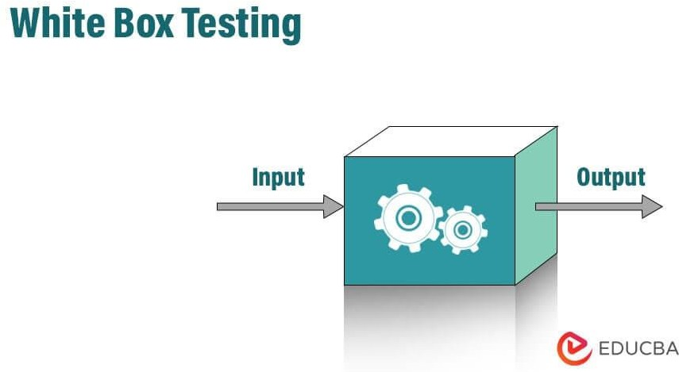
Fig 6.3.1 White-Box Testing Diagram

Black Box Testing
It is also known as Behavioural Testing, a software testing method in which the internal structure/design/implementation of the item being tested is not known to the tester. These tests can be functional or non-functional, though usually functional. This method is named so because the software program, in the eyes of the tester, is like a black box; inside which one cannot see. This method attempts to find errors in the following categories:
- Incorrect or missing functions
- Interface errors

- Errors in data structures or external database access
- Behaviour or performance errors
- Initialization and termination errors

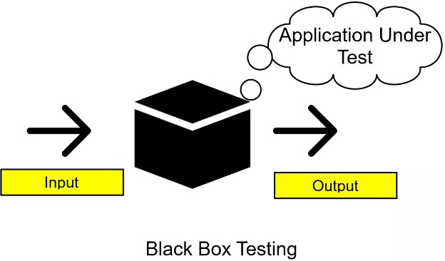

Fig 6.3.2 Black Box Testing

In the Table creation module, the tables are created with user-specified fields, and the user can create marry tables at a time. They may specify conditions, constraints and calculations in the creation of tables.

Test Plan

The test plan for the emotion-based music and game recommendation system involves several key steps to ensure robust functionality and user satisfaction. Initially, we will test the system's ability to handle voice input by uploading valid audio files and verifying that they are correctly recognised and processed. Next, we will evaluate the emotion prediction model's accuracy in identifying emotions from the voice clips. Following this, we will assess the system's capability to generate appropriate playlist recommendations using the spotify API, ensuring the playlists align with the predicted emotions. Similarly, we will test the game's recommendation component to confirm that it suggests games matching the user's emotional state. The plan also includes handling edge cases, such as invalid or low-quality audio inputs, to ensure the system gracefully manages errors and provides meaningful feedback to users. Additionally, we will test the system's performance under load by processing multiple audio files simultaneously to ensure consistent performance. Integration tests with the Spotify API and the game recommendation algorithm will be conducted to validate seamless communication and data exchange between systems. Finally, user feedback mechanisms will be tested to verify that feedback is accurately recorded and utilized for improving the

recommendation system. This comprehensive test plan aims to ensure the system is reliable, accurate, and user-friendly

Test Cases
Test case for Proceed Button

Test case ID | TC001
Pre-requisites | Python version 3.11
Action | Must be go to menu page to start process
Expected Result | Must be go to menu page to start process
Test Result | Pass

Table 6.4(a): Test case for Proceed Button

Test case for Login Button

Test case ID | TC002
Pre-requisites | Python version 3.11
Action | Enter credentials and click on the login button
Expected Result | User should be successfully logged in and redirected to the dashboard
Test Result | Pass

Table 6.4(b): Test case for Login Button

Test case for Source and Destination Input

Test case ID | TC003
Pre-requisites | User must be logged in
Action | Dataset need to read successfully
Expected Result | Route is accepted and displayed
Test Result | Pass

Table 6.4(c): Test case for Source and Destination Input

Test case for Map Route daily

Test case ID | TC004
Pre-requisites | Preprocessing part takes place
Action | Click on the “Show Route” button
Expected Result | System displays route map between entered locations
Test Result | Pass

Table 6.4(d): Test case for Map Route daily

Test case for Blackspot-Detection

Test case ID | TC005
Pre-requisites | Trained ML model and black spot dataset must be available
Action | System overlays black spots on the live route
Expected Result | Black spots appear correctly on the map
Test Result | Pass

Table 6.4(e): Test case for Blackspot-Detection

Test case for Safe Route Suggestion

Test case ID | TC006
Pre-requisites | Black spot detected on current route
Action | System evaluates and suggests alternate path
Expected Result | A safer route with fewer black spots is suggested
Test Result | Pass

Table 6.4(f): Test case for Safe Route Suggestion

SCREENS

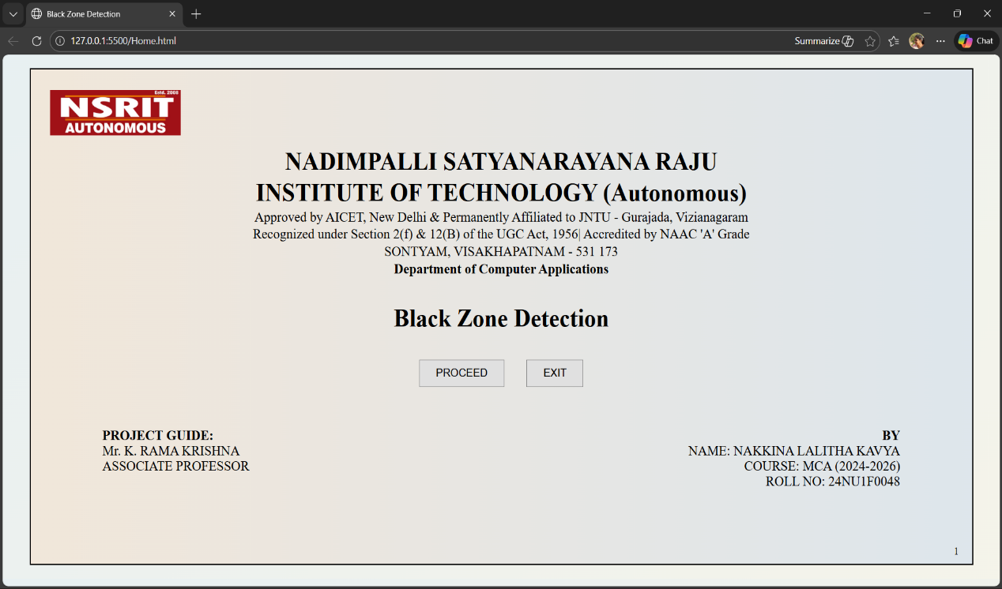

Fig. 7.1 Home Page
Project Execution starts from the welcome page having the title of the project. If the user click on “Proceed” button then it will take user into the menu page.

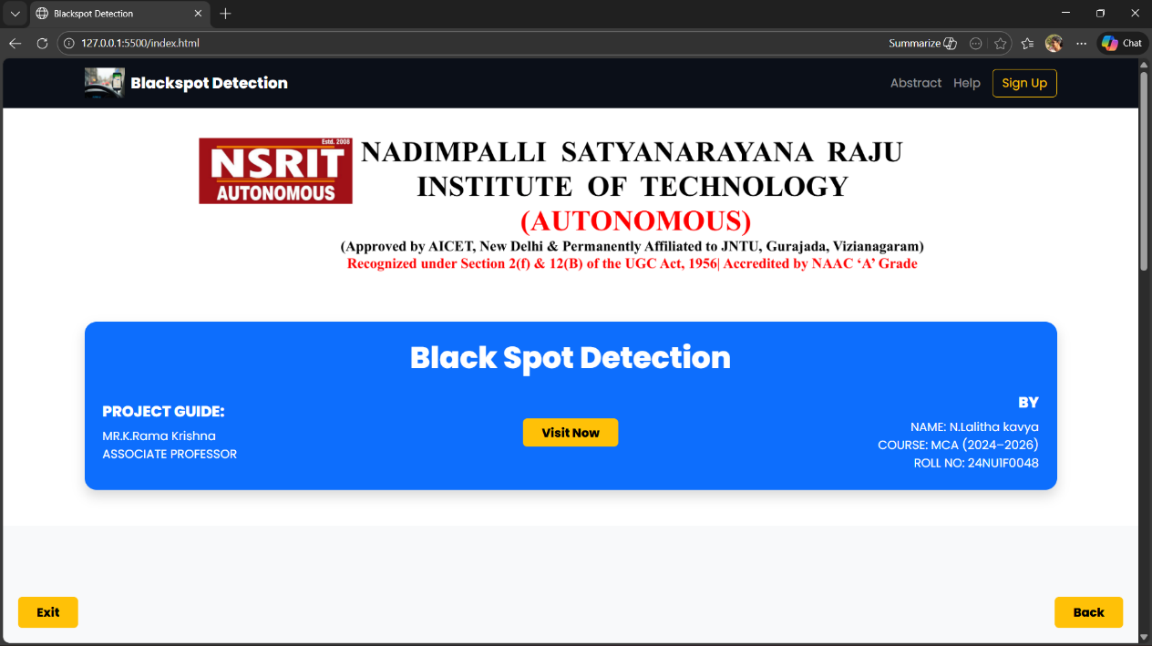

Fig. 7.2 Menu Page
If the user clicks on “Visit” button then it will display the login page of the application.

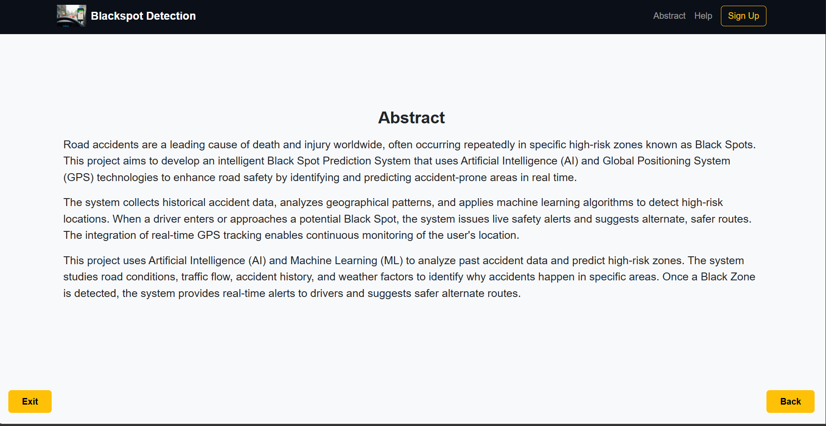

Fig. 7.3 Abstract page
If the user clicks on “Abstract” button then it will Scroll downs the Abstract page

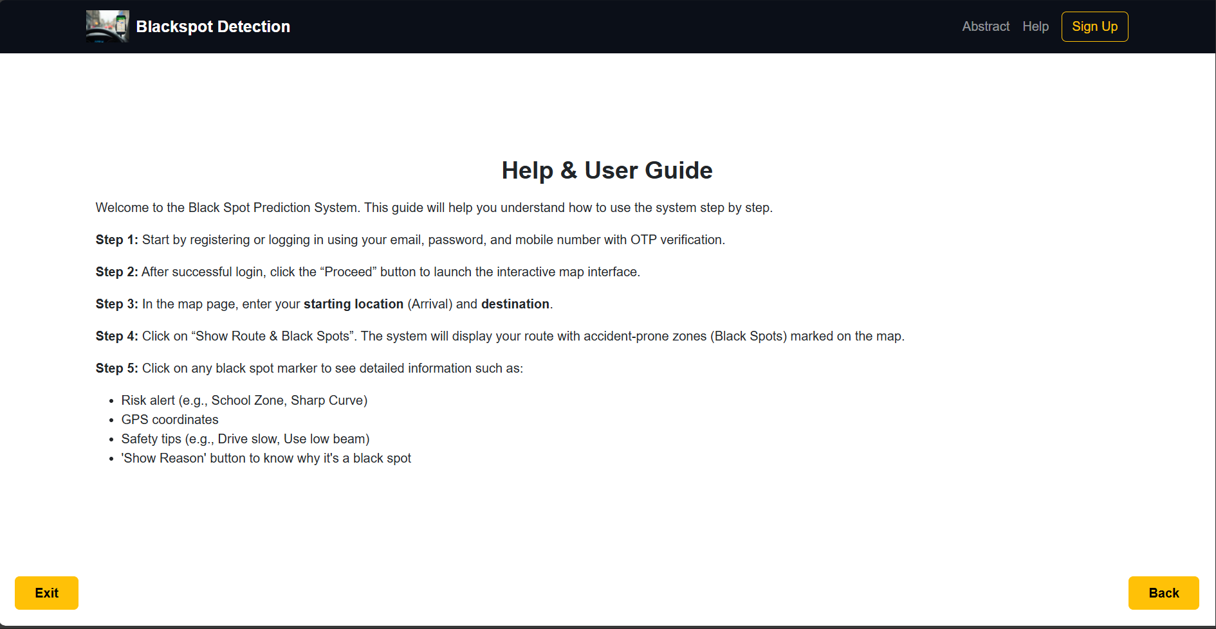

Fig. 7.4 Help & User page

If the user clicks on “Help” button then it will Scroll downs the Help page.

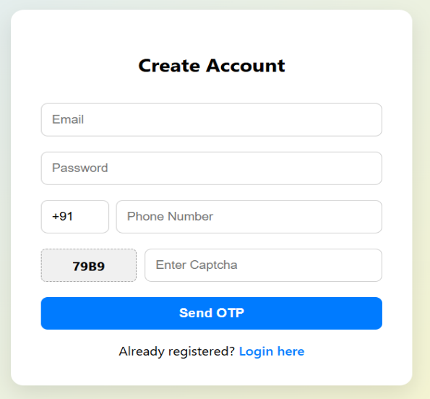

Fig. 7.5 Register page
On clicking “Register Button” then it redirects to the registration page and opens interface like this and user enter their personal details (OTP facility also Included)

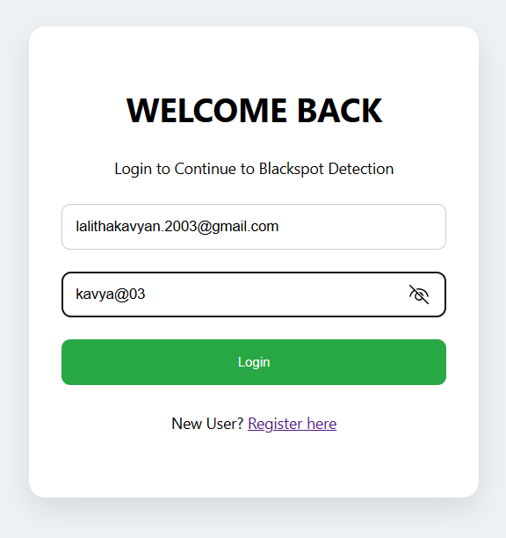

Fig. 7.5(a) Login Page
On Clicking “Login Button” then it redirects to the Login page and enter them personal details already given while Registered

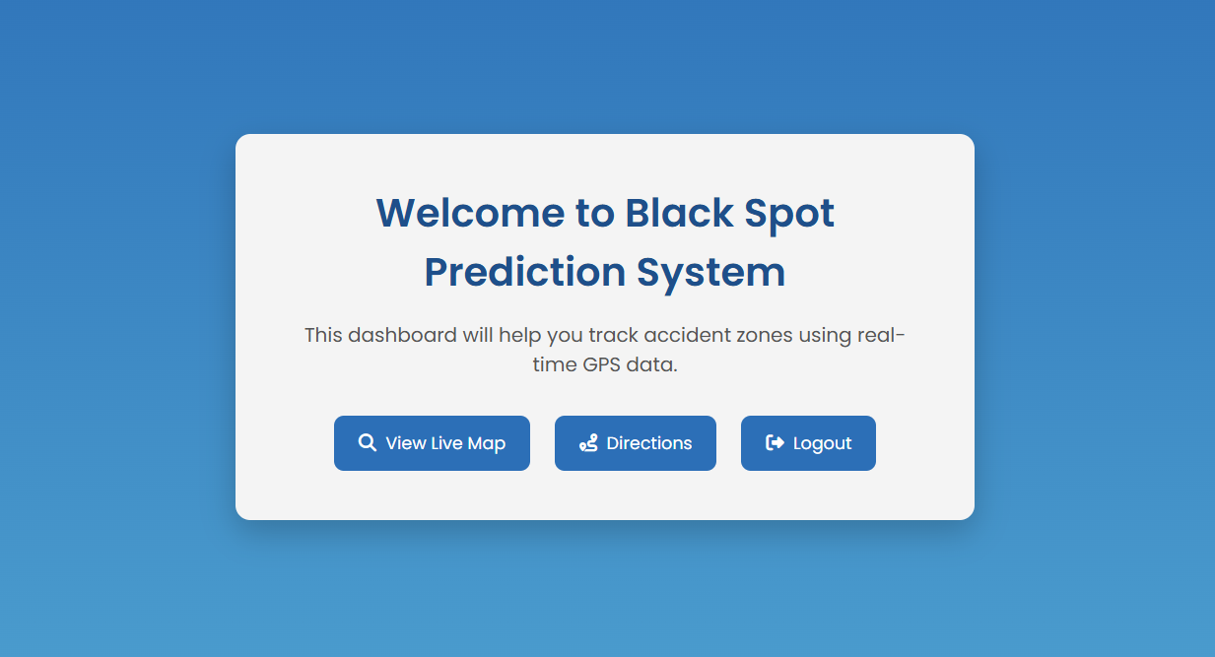

Fig. 7.6 Dashboard Page
Here is the dashboard Page enters after Login page which shows the Menu of the project

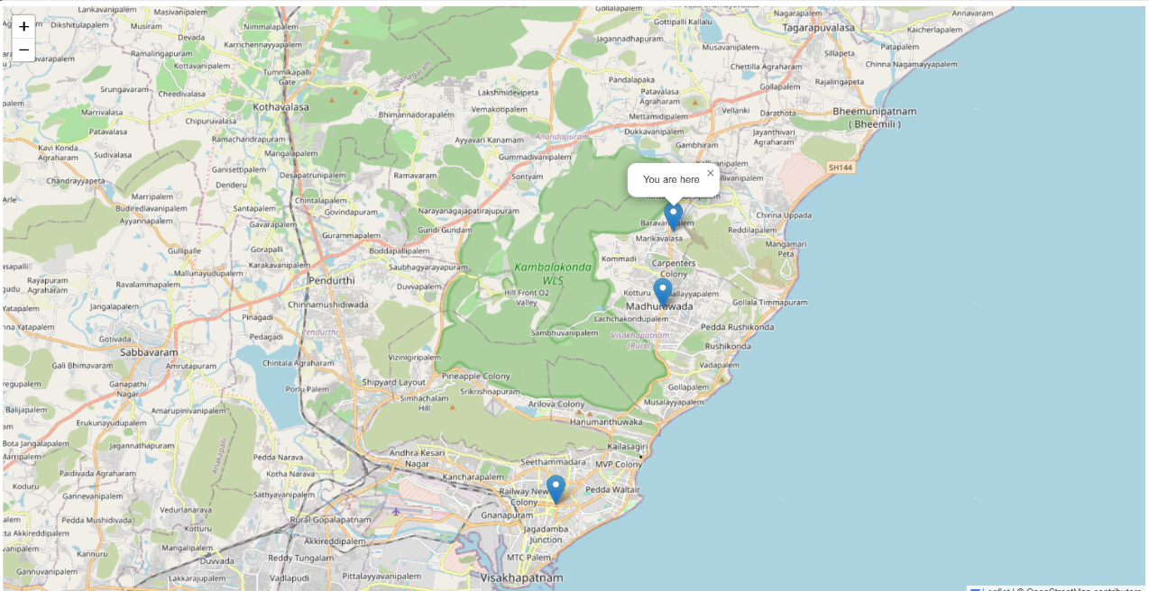

Fig. 7.7 Live Location page
After clicking “Live Location Button” on the dashboard page we go through the Live location directly through Maps, user can proceed further.

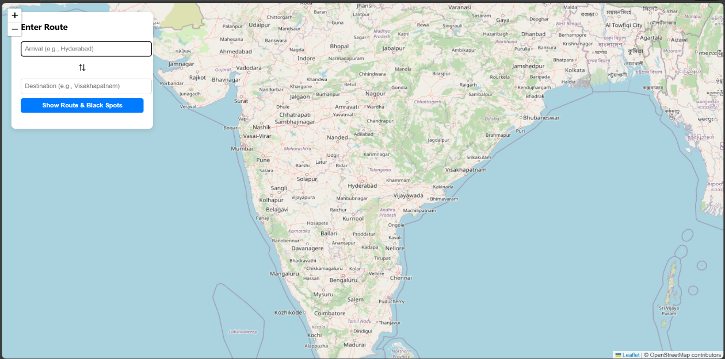

Fig. 7.7(a) Source & Destination page
The User click on the “directions” button on previous page will go through this page and enter the source & destination then it will get the result

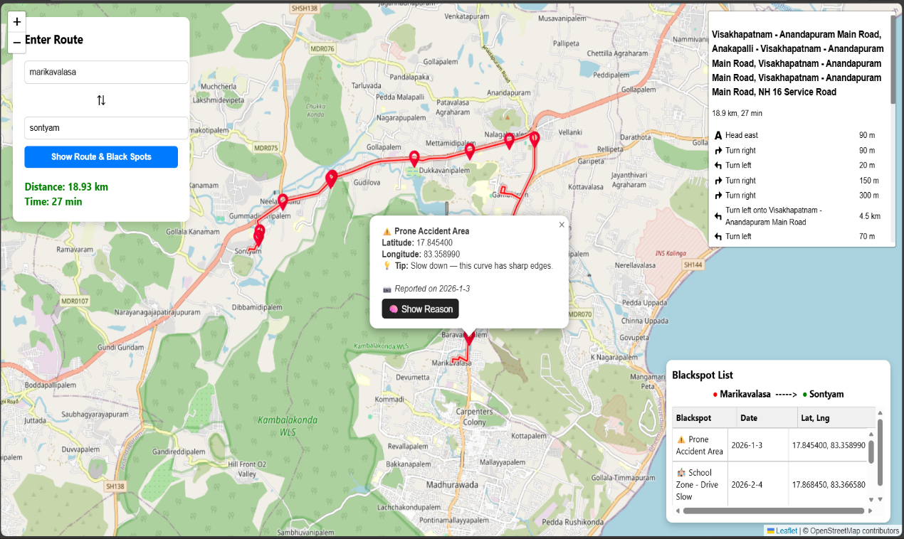

Fig. 7.7(b) Result page
After enter the Source & Destination address then it gives the result of directions, Blackspots in that direction and shows the route map. Shown in the Above Figure

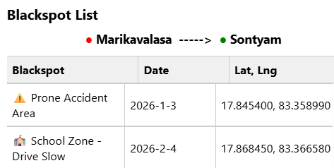

Fig. 7.8 Blackspot List Table
When click on the “Show Blackspot” Button then it will give you the list of the Blackspots while in the Route.

CONCLUSION

CONCLUSION
In conclusion, the Black Spot Prediction System using AI and GPS offers a modern and intelligent solution to one of the most critical problems in road transportation: the identification and prevention of accidents in high-risk zones, commonly known as black spots. By leveraging the power of machine learning algorithms and real-time GPS tracking, the system enhances road safety by dynamically detecting accident-prone areas and providing timely alerts to drivers. The integration of predictive modelling with spatial data allows the system to learn from historical accident records, identify hazardous patterns, and deliver live alerts when a user approaches a known danger zone. This capability significantly improves driver awareness, minimizes the risk of accidents, and supports proactive safety planning. Moreover, the use of interactive map visualizations and user-friendly interfaces ensures accessibility and ease of use for a broad range of users. Despite its many strengths, the system also comes with a few challenges. Effective prediction relies on high-quality, well-labelled accident datasets and precise location tracking. Inaccurate data or poor GPS signal quality can affect the reliability of predictions. Additionally, the AI models used for black spot detection require continuous training and updating to adapt to evolving traffic patterns and infrastructure changes. These challenges underscore the importance of ongoing data collection, model tuning, and system validation.

FUTURE SCOPE

The future scope of the Black Spot Prediction System using AI and GPS is highly promising and presents numerous avenues for advancement and integration. As technology evolves and intelligent transportation systems gain traction, the potential for enhancing this system grows significantly. One major direction is the integration of AI with real-time traffic and environmental data. Incorporating inputs such as weather conditions, traffic congestion, road surface quality, and real-time vehicle movement can help the model make more context-aware predictions, leading to higher accuracy and dynamic black spot identification. Another exciting development lies in the use of deep learning architectures, such as Recurrent Neural Networks (RNNs), LSTMs, or Transformers, to model complex spatial-temporal dependencies in accident trends. These models could uncover hidden patterns and improve the predictive power beyond traditional machine learning approaches. Additionally, the system can be extended with crowdsourcing capabilities, allowing users to report new black spots or validate existing ones. This would help keep the system updated with live feedback and ensure higher community engagement and data accuracy.

REFERENCES

REFERENCES

References
- A. Kumar and R. Singh, “A Machine Learning Approach for Road Accident Prediction,” International Journal of Engineering Research & Technology (IJERT), vol. 8, no. 6, pp. 45–49, June 2019.
- S. Sharma and M. Verma, “Black Spot Identification and Analysis Using GIS,” International Journal of Advanced Research in Engineering and Technology (IJARET), vol. 11, no. 4, pp. 20–30, 2020.
- A. Gupta and V. Mehta, “Road Safety and Accident Prevention Using Artificial Intelligence,” International Conference on Smart Technologies in Computer and Communication Engineering, 2020.
- P. Jain and N. Saini, “Predicting Accident Prone Areas Using Machine Learning,”
Journal of Traffic and Transportation Engineering, vol. 7, no. 3, pp. 215–223, 2021.

- N. Srivastava, “Application of Data Mining in Black Spot Identification,”
International Journal of Emerging Technology and Advanced Engineering, vol. 5, no. 9,
pp. 78–84, 2019.

- J. Brownlee, “Crash Hotspots Prediction with Machine Learning,” Machine Learning Mastery, [Online]. Available: https://machinelearningmastery.com/, 2021.
- Indian Ministry of Road Transport and Highways, “Road Accidents in India – 2020,” Government of India, New Delhi, Tech. Rep., 2021.
- D. Patel and M. Shah, “Integration of GPS with Real-Time Road Hazard Alerts,” Proceedings of the International Conference on Intelligent Transportation Systems, pp. 98–105, 2019.
- K. Yadav and R. Kumar, “Smart Route Planning with Black Spot Avoidance using AI,” IEEE International Conference on Intelligent Systems, pp. 220–226, 2020.
- OpenStreetMap Contributors, “Leaflet.js Documentation,” [Online]. Available: https://leafletjs.com/

APPENDIX

  - List of Figures

Figure No. | Figure Name | Page No.
Fig.3.4.1.2 | Use case Diagram | 30
Fig.3.4.2 | Sequence Diagram | 34
Fig.3.4.3 | Activity Diagram | 35
Fig. 4.3 | System’s Block Design | 37
Fig 4.5.1(a) | Classification of Random Forest | 39
Fig 6.3.1 | White-Box Testing Diagram | 89
Fig 6.3.2 | Black Box Testing | 90
Fig. 7.1 | Home Page | 94
Fig. 7.2 | Menu page | 94
Fig. 7.3 | Abstract page | 95
Fig. 7.4 | Help & Usage page | 95
Fig. 7.5 | Register page | 96
Fig. 7.5(a) | Login page | 96
Fig. 7.6 | Dashboard page | 97
Fig. 7.7 | Live location page | 97
Fig. 7.7(a) | Source & Destination page | 98
Fig. 7.7(b) | Result page | 98
Fig 7.8 | Blackspot List Table | 99

  - List of Tables

Table No. | Table Name | Page No.
Table 3.4.1.2(a) | Upload Dataset | 30
Table 3.4.1.2(b) | Read Dataset | 31
Table 3.4.1.2(c) | Model Training | 31
Table 3.4.1.2(d) | Model Testing | 31
Table 3.4.1.2(e) | Predict Black Spots on Route | 32
Table 3.4.1.2(f) | Display Route with Black Spots | 32
Table 3.4.1.2(g) | Real-Time Alert to User | 33
Table 3.4.1.2(h) | Admin Update Black Spot Data | 33
Table 6.4(a) | Test case for Proceed Button | 91
Table 6.4(b) | Test case for Login Button | 91
Table 6.4(c) | Test case for Source and Destination Input | 91
Table 6.4(d) | Test case for Map Route daily | 92
Table 6.4(e) | Test case for Blackspot-Detection | 92
Table 6.4(f) | Test case for Safe Route Suggestion | 92

